How to Search for
Knowledge Articles

Step 1: Log into the CWDS ServiceNow Customer Support Management (CSM) Portal
URL for reference - https://cwds.service-now.com/csm

Step 2: Once logged in you can access Knowledge Articles in two different ways:
- Option 1: From the home page, click on the word ‘Knowledge’:
- Option 2: Or from the top right of the portal, click on the ‘Knowledge’ tab.

Step 3: Once you complete the step above, you are routed to the ‘Knowledge Base’ landing page. Click on the Book icon to view current and active articles.
Figure 1 – Book Icon

Step 4: If you’d like to do a manual search for articles, you can type key words in the Knowledge Search Bar:
Figure 2 – Knowledge Search Bar
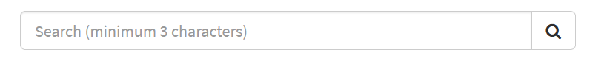
Please note: Using key words such as 'CARES' will suggest all Knowledge Articles with the word 'CARES' in it, which may confuse users who are searching for a CARES vs. a CARES-Live issue. Please review the suggested articles thoroughly to ensure you are reviewing the correct solution/workaround.

Step 5: When you’ve found an article, you can open and read through the article for solutions or workarounds to common problems. You can also rate and comment on the article.
Additional Notes: If you are unable to find an article related to an issue you are experiencing you can open a support ticket and an Agent will help resolve your issue.

