February 16, 2021 through March 15, 2021

VISION STATEMENT
“We will establish and maintain an innovative statewide 21st century information technology application that aids child welfare stakeholders in assuring the safety, permanency, and well-being of children at risk of abuse and neglect.”
Child Welfare Digital Services (CWDS) is a collaboration of California State and local government agencies that support our shared stakeholders through technology to assure the safety, permanencyy, and well-being of children at risk of abuse, neglect or exploitation. CWDS is responsible for maintaining and operating the existing Child Welfare Services / Case Management System (CWS/CMS) and the development of the Child Welfare Services – California Automated Response and Engagement System (CWS-CARES). We are dedicated to building a child welfare information system that responds to users’ needs while maintaining the best standards for security and data integrity to aid child welfare professionals in the vital assistance, oversight and case management of our most vulnerable populations.

HIGHLIGHTS
The CWS-CARES Project received approval of the Implementation Advance Planning Document (IAPD) on
February 24, 2021 from the Administration on Children, Youth and Families (ACYF). The approval included seven conditions, one of which necessitates submittal of an As-Needed APD that provides additional requirements, schedule, and implementation details for the Greenfield solution, which is a demonstration module, prior to the start of development work. The Project will work with the vendors to refine these details once onboarding is complete and anticipates submitting the As-Needed APD in June 2021.

On March 8, 2021, the CWS-CARES Project onboarded the Product Value Services (PVS) vendor, KPMG. The PVS vendor will help create solutions, add value to what the Project builds, and advocate for the State’s program goals for the CWS-CARES. The remaining key CWS-CARES procurements (Platform as a Service Systems Integrator SI [PaaS], CARES Data Infrastructure [CDI], Independent Advisor and Salesforce Licensing) are in progress with contract execution anticipated in April.

The CWS-CARES Product Delivery Team, in consultation with State and County Service Managers and other SMEs, continued work on identifying and researching the potential options to develop and implement a demonstration Greenfield module within the first six months of vendor onboarding. The Greenfield module will allow the Project to test out the new Salesforce Platform as a Service (PaaS) development and delivery approach, including the CDI, along with the accompanying Service Delivery Lifecycle (SDLC), and will provide CWDS with a means to demonstrate value to counties while establishing an effective implementation approach. The Project anticipates selecting the final Greenfield option in May 2021.

Planning workshops continued with State and County program and policy subject matter experts (SME) to review the Value Hypothesis framework that will help determine product requirements and setting clear priorities, including those associated with candidate greenfield modules. This work will focus on greater understanding of the Integrated Core Practice Model (ICPM) behaviors, program goals and outcomes, by each process area. A Value Hypothesis is what the CWS-CARES SMEs and project team members develop as a testable theory of the value certain product features might deliver to child safety, permanence and well-being if built. The reason why this concept is so important is because it helps prioritize which features will deliver the most impact towards goals, and it connects the dots between process efficiencies, practice behaviors, program goals, and child and family outcomes.

In addition, the Project continued to meet with the California Department of Technology (CDT) and the Department of Finance (DOF) to review the Special Project Report (SPR) 4 draft that was submitted on January 11, 2021. The Project continues to collaborate with the CDT and DOF to refine the SPR 4 for formal submission in March 2021.

On February 22, 2021, the CDSS Branch Chief on the CWDS Executive Leadership Team (ELT) departed from the Project. An interim CDSS Branch Chief was appointed while CDSS seeks to fill this position. The appointee also serves as the Service Manager for Resource Management on the CWS-CARES Project and brings with her 17 years of experience in managing state administrative services as well as experience in strategic planning, fiscal forecasting, and project management.

KEY PROJECT MILESTONES
Milestone | Planned Finish Date | Actual Finish Date | Status | Notes
Independent Advisor | 02/15/21 |  | See Notes | Evaluations for this solicitation are scheduled for completion on March 16, 2021, with interviews tentatively scheduled for March 17 through March 18. Negotiations are anticipated to take place between March 22 and March 23.
Independent Advisor Contract Award | 03/16/2021 |  | See Notes | The contract execution date of this procurement is anticipated in April 2021.
Salesforce Licenses Subscription Solicitation Release | 03/30/20 |  | In Progress | This procurement is in progress and the release is scheduled for  April 2021.
IAPD Approved by ACYF | 05/30/20 |  | Completed | The Project received ACYF approval for the IAPD on February 24, 2021. The IAPD provides the Project with Federal Financial Participation (FFP) through December 31, 2021.
Salesforce License Subscription Contract Award | 06/02/20 |  | Delayed | This procurement is in progress and anticipated contract award in  April 2021.
PVS Contract Award | 07/20/20 |  | Completed | This contract was executed on February 28, 2021 with vendor onboarding occurring on  March 8, 2021.
PaaS Systems Integrator Services Contract Award | 08/11/20 |  | Delayed | An intent to award was issued 02/23/2021 and is pending ACYF review and approval. The contract execution is anticipated in April 2021.
Special Project Report 4 (SPR 4) Draft Submission | 07/20/20 | 1/11/2021 | Completed | The draft SPR 4 was submitted to CDT on January 11, 2021. The formal submission of SPR 4 is scheduled for March 2021.
FY 2021/22 Budget Change Proposal (BCP) Submission | 08/28/20 | 2/10/2021 | Completed | 21/22 budget request submitted
Special Project Report 4 (SPR 4) Final Submission | 03/20/2021 |  | In Progress | The SPR is routing for signatures prior to formal submission. The target submission date to CDT is March 19, 2021.
CDI Contract Award | 10/02/20 |  | In Progress | The CDI solicitation was rereleased on 12/4/2020 based on the CWS-CARES Path Forward agreement. The intent to award was completed on March 10, 2021 with contract execution anticipated in April 2021.
Quarterly Updates to Roadmaps  (FY 2020/21 Q3) | 03/31/21 | 03/31/21 | Completed
Quarterly Updates to Roadmaps  (FY 2020/21 Q4) | 06/30/21

CARES IMPLEMENTATION STATUS

Implementation Planning Activities
Implementation Activities
- Continued to organize and conduct bi-weekly meetings with the chartered workgroup assembled to support the Master Plan for CARES Implementation
- Continued to organize and conduct meetings with the repository subgroup in support of the repository development and planning milestone. This subgroup:
  - Continued to identify low-level requirements, data schema, and user flow diagram
  - Continued to refine specific tasks
- Continued refinement of items to be included in the CARES county organization assessment
- Continued to support formal review and finalization of the CARES Implementation Services RFO
- Continued vendor onboarding planning
- Continued detailed discussions related to CARES Sandbox and Cutover/Data Conversion
- Finalized implementation planning efforts related to CARES-Live 90-Day Password Reset
Organizational Change Management (County OCM)
- Presented at several Regional User Group meetings, the CWS/CMS Oversight Committee, and during the monthly CARES-Live and Implementation call to provide updates regarding implementation and CARES-Live
- Continued planning related to county CARES implementation contacts
System Training/User Training
- Continued to provide support to CWDS and CDSS regarding new user groups getting access to CARES-Live
- Updated training job aid in support of the CARES-Live 90-Day Password Reset
- Created a support plan for the 90-Day Password Reset rollout

CARES-LIVE RELEASE STATUS

Product Feature/Service - Progress to Date
The Project made the decision in May 2019 to pause all new development, which means that no new functionality or features will be introduced to CARES-Live. The Project, however, remains committed to maintaining the integrity of the existing CARES-Live system, with an emphasis on increasing system efficiency for all users.

CARES-Live METRICS
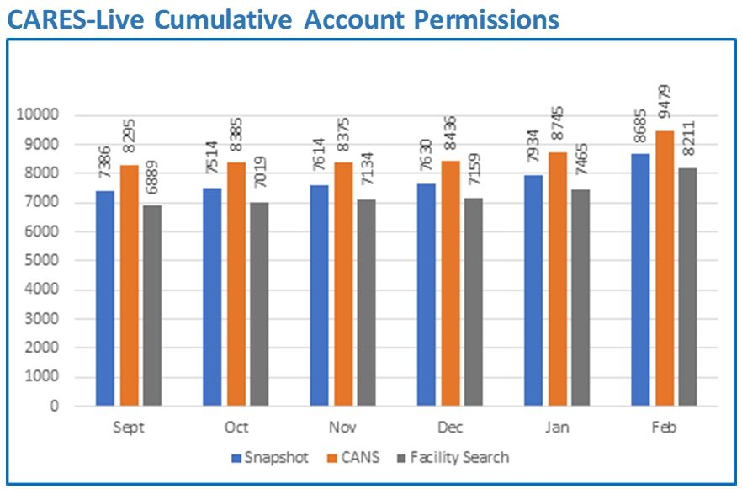

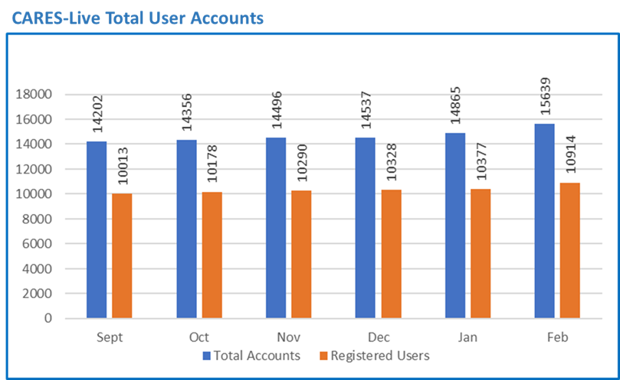

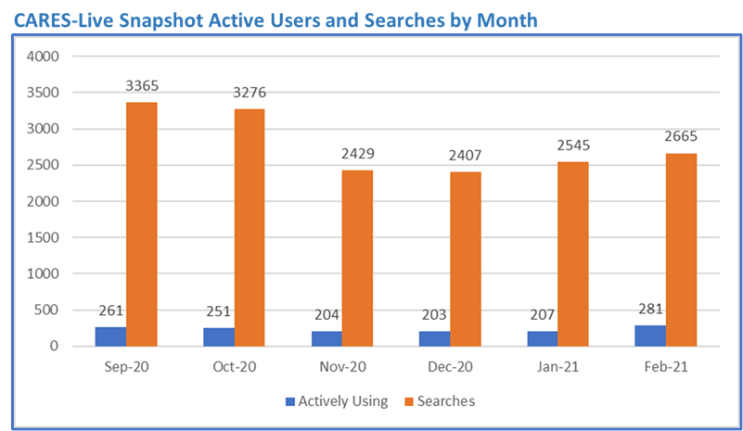

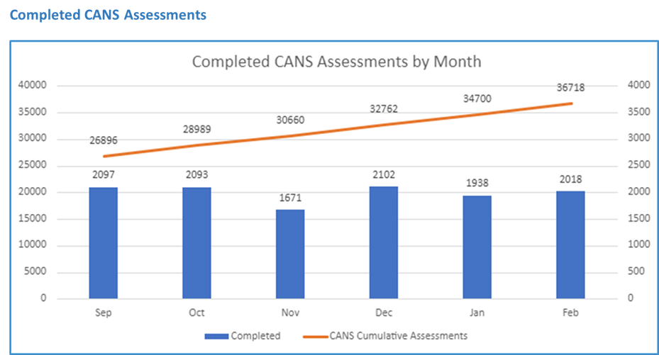

STAFFING VACANCY
Current Vacancy Rate: 10%
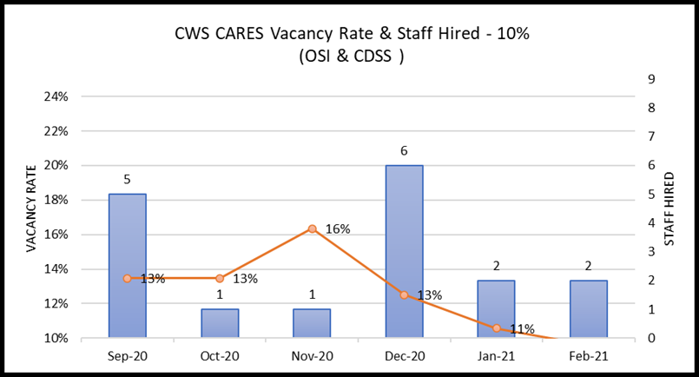
The vacancy rate decreased to 10% as depicted in the graph above. There are 10 vacant positions of the 104 CWS-CARES project total. Those are depicted in the below table along with the recruitment status. Of the 10 vacancies, 5 have the Request for Personnel Action (RPA) in review with Office of System Integration (OSI) Human Resources Division.
Entity  CWS-CARES | Classification | Service Team | Date Vacant | # of Days  Vacant | Status
OSI | Information Technology Associate | Service Desk | 2/5/2021 | 23 | RPA
OSI | Information Technology Associate | Application Developer | 7/8/2017 | 1331 | RPA
OSI | Information Technology Manager II | Director of Technology | 10/1/2020 | 150 | Interview / Screening
OSI | Information Technology Specialist I | Application Developer | 7/19/2017 | 1320 | Strategic Hold
OSI | Information Technology Specialist I | Developer / Data Scientist | 1/31/2020 | 394 | RPA
OSI | Information Technology Specialist I | DevOps Engineering | 5/23/2020 | 281 | RPA / Re-advertisement
OSI | Information Technology Specialist I | Implementation/Training | 11/1/2020 | 119 | Interview / Screening
OSI | Information Technology Specialist I | Product Development | 11/13/2020 | 107 | Tentative Offer Made
OSI | Information Technology Specialist II | DevOps Engineering | 7/31/2017 | 1308 | RPA / Re-advertisement
OSI | Information Technology Specialist II | Application Architect | 8/9/2017 | 1299 | Strategic Hold

Filled Positions
Entity  CWS-CARES | Classification | Service Team | Date Vacant | # of Days  Vacant | Efforts/Notes
OSI | Information Technology Associate | Web Team | 10/19/2020 | 133 | Position Filled. Effective Start Date: 3/1/21
OSI | Information Technology Specialist I | Service Desk | 12/31/2020 | 36 | Position Filled. Effective Start Date: 2/5/21

RISKS
For the February reporting period, there is one continuing High Priority risk open. No new High Priority risks were opened or closed for this reporting period. The below table provides details each High Priority risk being actively managed by the PMO.

Continued Risks
Continued Risks | Impact | Resolution
Vendor Management and Coordination  RI-154  Description:  The coordination and mutual dependency in developing CARES requires higher degree of vendor management (PVS, PaaS, IS and CDI) that the Project needs to address. The Project needs to develop a plan and methodology of how we will manage the work and communication across the development of the PaaS solution. | Without an effective vendor management plan, issues will develop that will adversely affect project schedule, scope and cost. Close coordination is required between the four major components of CWS-CARES (CARES application, CDI, Data Conversion, County Implementation) | The Project will develop new Vendor Management Plan and host the vendor management training session for all state managers.  Progress as of March 15, 2021:  Training and organizational change management efforts are underway for new vendor management processes and will continue through the months of February and March.

ISSUES
For the February reporting period, there are no High Priority issues open. No new High Priority issues were opened or closed for this reporting period.

BUDGET/EXPENDITURES
as of march 15, 2021

2020-21 CWS-CARES Budget/Expenditure Report Summary
(Footnotes below)
OSI Spending Authority Budget Item | 2020-21 Budget¹ | Actual Expenditures
Personal Services* | $9,996,256 | $5,001,051
Other OE&E** | $6,244,583 | $1,245,105
Data Center Services** | $4,640,000 | $1,177,076
Contract Services** | $23,904,473 | $4,907,862
Enterprise Services* | $3,045,032 | $1,527,366
OSI Spending Authority Total | $47,830,344 | $13,858,460

CDSS Local Assistance Budget Item | 2020-21 Budget | Actual Expenditures
Contract Services*** | $664,800 | $437,792
Other OE&E*** | - | -
County Participation Costs*** | $3,200,000 | $37,075
CDSS Local Assistance Total | $3,864,800 | $474,867

CDSS State Operations Budget Item | 2020-21 Budget | Actual Expenditures
Personal Services*** | $1,930,359 | $1,825,753
Facilities**** | $568,000 | $231,944
Other OE&E*** | $224,497 | $130,634
CDSS State Operations Total | $2,722,856 | $2,188,331

Project Totals | 2020-21 Budget | Actual Expenditures
CWS-CARES Project Total | $54,418,000 | $16,521,658

Budget/Expenditures Footnotes:
1 2020-21 Budget reflects amount in approved Special Project Report 3, plus BL Adjustments 19-24, 19-29, 20-29, 20-33 and 20-34
* Actuals through January 2021 per FI$Cal Report
** Actuals from January 2021 FI$Cal Reports, in addition to processed invoices through March 15, 2021
*** Actuals from CDSS as of January 2021
**** Actuals from CDSS through January 2021

Questions? Email CWDS Communications: comms@cwds.ca.gov

Data through February 28, 2021.
Data through February 28, 2021.
Personal Services expenditures have been updated to reflect the recent FI$Cal adjustments and subsequent updated cost allocation. Facilities and Other OE&E in review until CWS-CARES costs can be isolated.

