October 16, 2020 through November 15, 2020

VISION STATEMENT
“We will establish and maintain an innovative statewide 21st century information technology application that aids child welfare stakeholders in assuring the safety, permanency, and well-being of children at risk of abuse and neglect.”
Child Welfare Digital Services (CWDS) is a collaboration of California State and local government agencies that support our shared stakeholders through technology to assure the safety, permanency and well-being of children at risk of abuse, neglect or exploitation. CWDS is responsible for maintaining and operating the existing Child Welfare Services / Case Management System (CWS/CMS) and the development of the Child Welfare Services – California Automated Response and Engagement System (CWS-CARES). We are dedicated to building a child welfare information system that responds to users’ needs while maintaining the best standards for security and data integrity to aid child welfare professionals in the vital assistance, oversight and case management of our most vulnerable populations.

HIGHLIGHTS
The State continues to strategically realign the CWS-CARES procurements to support the improved project approach and plans for implementation. The project will be submitting a revised Implementation APD (IAPD) to ACYF by December 31, 2020 that will reflect the State’s approach to building the new CARES solution. On November 3, 2020, the State submitted a CWS-CARES Planning As-Needed Advance Planning Document (APD) requesting approval to release the procurements for the Platform as a Service Systems Integrator, CARES Data Infrastructure, Independent Advisor, and Product Value Services. The goal is to award these contracts in early 2021 and begin design and development for the new CARES as early as February.

Product development has completed the updates to the Product Playbook that focused on Context Setting, Prioritization, Discovery, and Prototyping phases. Updates to refine the Tactical Guides were completed for Blueprinting, Policy Practice and Value Hypothesis (a logic model that shows the relationship between process/practice variables and child and family outcomes). Product development planning work continues, which consists of CARES Product Roadmap refinement to determine logical sequencing and dependencies for efficient iterative development. Workshops continued with State and County program and policy experts to complete the Value Hypothesis work that is a part of the Context Setting phase of the Service Delivery Life Cycle. This work helps project team members connect the dots between the Integrated Core Practice Model (ICPM) behaviors, program goals and outcomes, by process areas. The Project team continued work on developing a plan to ensure engagement of counties and county consultants throughout the development of the CARES. This plan will provide a tool to educate new project team members and estimate the costs for county participation.

The CWDS Deputy Director announced her retirement on October 9th and departed from the Project on November 1st. OSI is in the process of recruiting a replacement for this position. In the interim, an Acting Deputy Director has been appointed.

KEY PROJECT MILESTONES
Milestone | Planned Finish Date | Actual Finish Date | Status | Notes
Platform as a Service (PaaS) Systems Integrator Services Solicitation Release | 12/11/19 | 11/07/19 | See Notes | The PaaS Systems Integrator solicitation was re-released on November 20, 2020.
Product Values Services (PVS) Solicitation Release | 03/17/20 | 02/05/20 | See Notes | The PVS solicitation planned for re-release in November 2020.
CDI Solicitation Release | 03/27/20 | 06/25/2020 | See Notes | The CDI solicitation planned for re-release in December 2020.1
Independent Advisor | 02/15/21 |  | See Notes | The Independent Advisor solicitation planned for re-release in November 2020. 1
Salesforce Licenses Subscription Solicitation Release | 03/30/20 |  | In Progress | The Project procured Limited Term licenses during the planning phase for training and discovery. CDT will negotiate this procurement and it will require ACYF’s approval.
Governance Plan Update Complete | 04/01/20 | 7/30/2020 | See Notes | The Governance Plan will require further updates based on the State’s strategic procurement realignment.
Implementation Advance Planning Document Submitted to ACYF | 04/01/20 | 07/30/2020 | See Notes | A revised IAPD will be submitted to ACYF in December 2020 that reflects the State’s strategic procurement realignment.
Quarterly Updates to Roadmaps  (FY 2019/20 Q4) | 04/02/20 | 07/30/2020 | See Notes | The Product and Project Roadmaps will be updated to reflect the State’s strategic procurement realignment.
IAPD Approved by ACYF | 05/30/20 |  | See Notes | On October 13, 2020, ACYF approved the Project’s As-Needed that requested an extension of time for project planning activities through 12/31/2020.
Salesforce License Subscription Contract Award | 06/02/20 |  | Delayed | CDT will negotiate this procurement and it will require ACYF’s approval.
PVS Contract Award | 07/20/20 |  | Delayed | Delayed – new solicitation planned for release in November 2020.
PaaS Systems Integrator Services Contract Award | 08/11/20 |  | Delayed | Delayed – new solicitation released on November 20, 2020.
Quarterly Updates to Roadmaps (FY 2020/21 Q1 | 09/30/20 |  | Delayed | The Product and Project Roadmaps will be updated to reflect the State’s strategic realignment.
Special Project Report 4 (SPR 4) Submission | 07/20/20 |  | Delayed | SPR 4 is submission is delayed and will now reflect the State’s strategic procurement realignment.
FY 2021/22 Budget Change Proposal (BCP) Submission | 08/28/20 |  | Complete | The Fall BCP draft was submitted to OSI Fiscal in August 2020; awaiting determination for submission to DOF.
CDI Contract Award | 10/02/20 |  | Delayed | Delayed – new solicitation planned for release in December 2020.
Quarterly Updates to Roadmaps  (FY 2020/21 Q2) | 12/31/20
Quarterly Updates to Roadmaps  (FY 2020/21 Q3) | 03/31/21
Quarterly Updates to Roadmaps  (FY 2020/21 Q4) | 06/30/21

CARES IMPLEMENTATION STATUS

Implementation Planning Activities
Implementation Activities
- Continued to organize and conduct bi-weekly meetings with the chartered workgroup assembled to support the Master Plan for CARES Implementation Project
- Continued to organize and conduct meetings with the Repository subgroup in support of the Repository Development and Planning Milestone. This subgroup:
  - Continued to identify high- and low-level requirements and started to draft the data schema
  - Continued to refine schedule and specific tasks
- Continued to organize and conduct meetings with the Assessment subgroup in support of the Create Assessment Milestone. This subgroup:
  - Identified items to be included in the county assessment
  - Started to gather feedback on assessment items
- Continued development of a Statement of Work (SOW) for the CARES Implementation Services Procurement
- Continued to identify county participation to support funding planning and milestones related to the Master Plan for CARES Implementation Project
Organizational Change Management (County OCM)
- Identified OCM items to be incorporated into the Create Assessment Milestone
- Presented at several Regional User Group meetings, CWS/CMS Oversight Committee, and during the monthly CARES-Live and Implementation call to provide updates regarding implementation and CARES-Live
System Training/User Training
- Identified training items to be incorporated into the Create Assessment Milestone
- Identified training support needs for new Behavioral Health workers that will access CARES-Live to enter CANS assessments
- Continued work to make all CARES-Live training material ADA compliant

CARES-LIVE RELEASE STATUS

Product Feature/Service - Progress to Date
The Project made the decision in May 2019 to pause all new development, which means that no new functionality or features will be introduced to CARES-Live. The Project, however, remains committed to maintaining the integrity of the existing CARES-Live system, with an emphasis on increasing system efficiency for all users.

CARES-Live METRICS
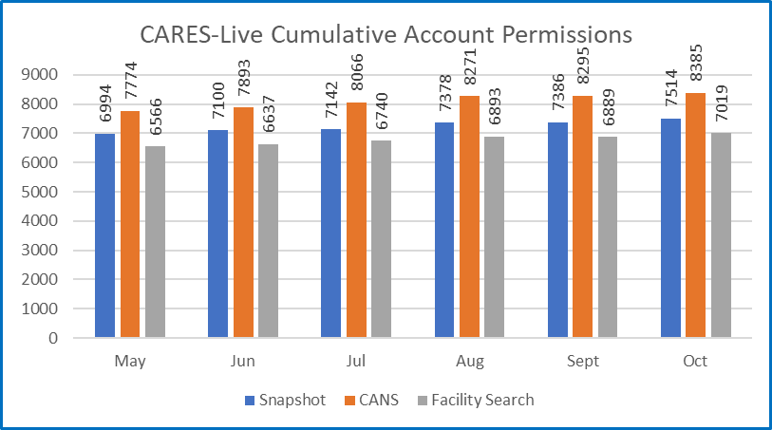

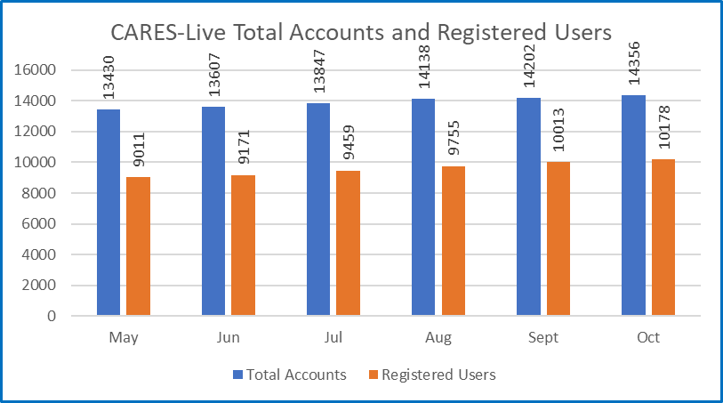

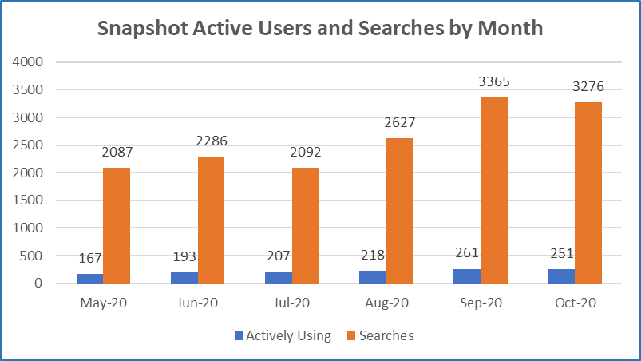

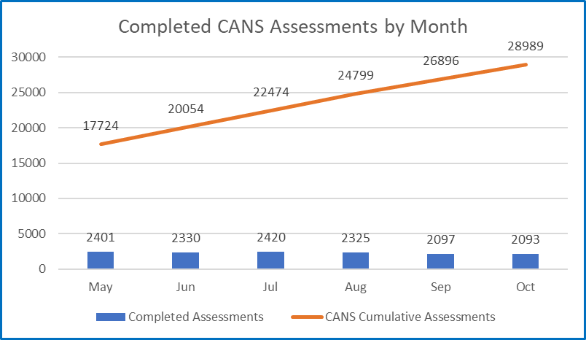

STAFFING VACANCY
Current Vacancy Rate: 13%
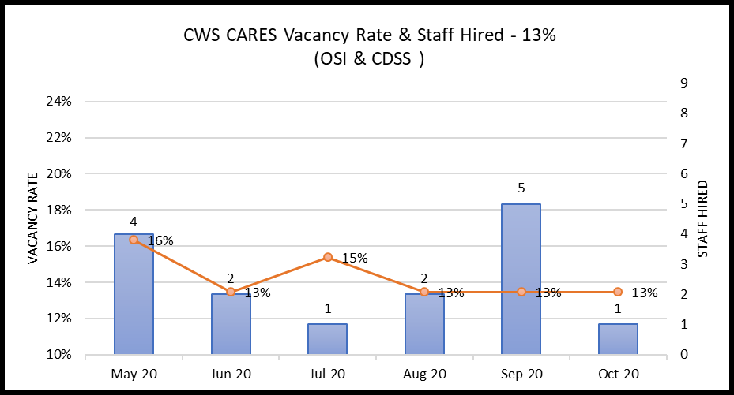
The vacancy rate remained at 13% as depicted in the graph above. There are 14 vacant position of the 104 CWS-CARES project total. Those are depicted in the below table along with the recruitment status. Of the 14 vacancies, 4 have the Request for Personnel Action (RPA) in review with Office of System Integration (OSI) Human Resources Division.
Entity  CWS-CARES | Classification | Service Team | Date Vacant | # of Days  Vacant | Status
OSI | Information Technology Associate | Developer | 7/8/2017 | 1211 | RPA
OSI | Information Technology Associate | Project Management Office Analyst | 9/14/2020 | 47 | Advertised – Final Filing Date of 10/31/20
OSI | Information Technology Manager II | Chief Technology Officer | 10/1/2020 | 30 | Strategic Hold
OSI | Information Technology Specialist I | Application Developer | 7/19/2017 | 1200 | Strategic Hold
OSI | Information Technology Specialist I | Information Security Analyst | 12/4/2019 | 332 | Advertised – Final Filing Date of 11/2/20
OSI | Information Technology Specialist I | Developer / Data Scientist | 1/31/2020 | 274 | RPA
OSI | Information Technology Specialist I | Customer Relations | 8/31/2020 | 61 | Advertised – Final Filing Date of 10/31/20
OSI | Information Technology Specialist I | Information Security Analyst | 10/1/2020 | 30 | Advertised – Final Filing Date of 11/2/20
OSI | Information Technology Specialist II | DevOps Engineering | 7/31/2017 | 1188 | RPA / Re-advertisement
OSI | Information Technology Specialist II | Application Architect | 8/9/2017 | 1179 | Strategic Hold
OSI | Information Technology Specialist II | Information Security Analyst | 9/14/2019 | 413 | Advertised – Final Filing Date of 11/2/20
OSI | Information Technology Supervisor II | Product Delivery Supervisor | 8/1/2019 | 457 | Interviewing / Screening
OSI | Office Technician (Typing) | Administrative Services | 9/14/2020 | 47 | Advertised – Final Filing Date of 10/31/20
CDSS | Staff Services Manager I | Data/Business Requirements Unit | 9/21/2020 | 40 | RPA

Filled Positions
Entity  CWS-CARES | Classification | Service Team | Date Vacant | # of Days  Vacant | Efforts/Notes
OSI | Information Technology Specialist I | Configuration Analyst | 7/30/2019 | 473 | Position Filled; Start Date of 10/14/2020

RISKS
For the November reporting period, there is one High Priority risk open. No new High Priority risks were opened or closed for this reporting period. There is one continuing High Priority risk. The below table provides details each High Priority risk being actively managed by the PMO.

Continued Risks
Continued Risks | Impact | Resolution
Vendor Management and Coordination  RI-154  Description:  The coordination and mutual dependency in developing CARES requires higher degree of vendor management (PVS, PaaS, IS and CDI) that the Project needs to address. The Project needs to develop a plan and methodology of how we will manage the work and communication across the development of the PaaS solution. | Without an effective vendor management plan, issues will develop that will adversely affect project schedule, scope and cost. Close coordination is required between the four major components of CWS-CARES (CARES application, CDI, Data Conversion, County Implementation) | The Project will develop new Vendor Management Plan and host the vendor management training session for all state managers.  Progress as of November 15, 2020:  Training for state managers on the vendor management process began in September and will continue through the month of Dec 2020 to include newly hired managers.

ISSUES
For the November reporting period, there are no High Priority issues open. No new High Priority issues were opened or closed for this reporting period.

BUDGET/EXPENDITURES
as of November 15, 2020

2020-21 CWS-CARES Budget/Expenditure Report Summary
(Footnotes below)
OSI Spending Authority Budget Item | 2020-21 Budget¹ | Actual Expenditures
Personal Services* | $10,444,256 | $1,973,942
Other OE&E** | $6,787,607 | $421,880
Data Center Services** | $4,640,000 | $379,340
Contract Services** | $23,361,449 | $2,529,095
Enterprise Services* | $3,248,032 | $431,900
OSI Spending Authority Total | $48,481,344 | $5,736,157

CDSS Local Assistance Budget Item | 2020-21 Budget | Actual Expenditures
Contract Services*** | $564,800 | $137,892
Other OE&E*** | - | -
County Participation Costs*** | $3,300,000 | -
CDSS Local Assistance Total | $3,864,800 | $137,892

CDSS State Operations Budget Item | 2020-21 Budget | Actual Expenditures
Personal Services**** | $1,930,359 | -
Facilities**** | $568,000 | -
Other OE&E**** | $224,497 | -
CDSS State Operations Total | $2,722,856 | -

Project Totals | 2020-21 Budget | Actual Expenditures
CWS-CARES Project Total | $55,069,000 | $5,874,050

Budget/Expenditures Footnotes:
1 2020-21 Budget reflects amount in approved Special Project Report 3, plus BL Adjustments 19-24 and 19-29
* Actuals through September 2020 per FI$Cal Report
** Actuals from September 2020 FI$Cal Reports, in addition to processed invoices through November 12, 2020
*** Actuals from CDSS as of September 2020
**** No Actuals to report

Questions? Email CWDS Communications: comms@cwds.ca.gov

Contingent upon ACYF approval.
Data through October 31, 2020.
Data through October 31, 2020.
Personal Services expenditures have been updated to reflect the recent FI$Cal adjustments and subsequent updated cost allocation. Facilities and Other OE&E in review until CWS-CARES costs can be isolated.

