September 16, 2020 through October 15, 2020

VISION STATEMENT
“We will establish and maintain an innovative statewide 21st century information technology application that aids child welfare stakeholders in assuring the safety, permanency, and well-being of children at risk of abuse and neglect.”
Child Welfare Digital Services (CWDS) is a collaboration of California State and local government agencies that support our shared stakeholders through technology to assure the safety, permanency and well-being of children at risk of abuse, neglect or exploitation. CWDS is responsible for maintaining and operating the existing Child Welfare Services / Case Management System (CWS/CMS) and the development of the Child Welfare Services – California Automated Response and Engagement System (CWS-CARES). We are dedicated to building a child welfare information system that responds to users’ needs while maintaining the best standards for security and data integrity to aid child welfare professionals in the vital assistance, oversight and case management of our most vulnerable populations.

HIGHLIGHTS
On October 13, 2020, the Administration on Children, Youth and Families (ACYF) approved the Project’s As-Needed Advance Planning Document (APD) that requested an extension of time for project planning activities through the end of the calendar year. In the approval letter, ACYF detailed the conditions required for continuation of project planning activities and funding through December 31, 2020. The State is strategically realigning the CWS-CARES procurements to support the improved project approach and plans for implementation. The project will be submitting a revised Implementation APD (IAPD) to ACYF by December 31, 2020 that will reflect the State’s approach to building the new CARES solution.
The procurements for the Platform as a Service System Integrator, CARES Data Infrastructure and Product Value Services will be reissued this fall, contingent upon ACYF approval. The goal is to award these contracts in early 2021 and begin design and development for the new CARES as early as February.
Product development planning continued, which consists of CARES Product Roadmap refinement to determine logical sequencing and dependencies for efficient iterative development. The Project team continued updating the Product Playbook with a focus on the Context Setting, Prioritization, Discovery, and Prototyping phases. Work was also completed on refining the Tactical Guides for Blueprinting, Policy Practice and Value Hypothesis (a logic model that shows the relationship between process/practice variables and child and family outcomes). Workshops continued with State and County program and policy experts to complete the Value Hypothesis work that is a part of the Context Setting phase of the Service Delivery Life Cycle. This work will help project team members connect the dots between the Integrated Core Practice Model (ICPM) behaviors, program goals and outcomes, by process areas. The Project team has been developing a plan to ensure engagement of counties and county consultants throughout the development of the CARES. This plan will provide a tool to educate new project team members and estimate the costs for county participation.

KEY PROJECT MILESTONES
Milestone | Planned Finish Date | Actual Finish Date | Status | Notes
Special Project Report 3 (SPR 3) Submission | 11/30/19 | 02/07/20 | Completed | On February 28, 2020, CDT approved the Special Project Report (SPR) 3 with a set of five conditions.
Platform as a Service (PaaS) Integration Services Solicitation Release | 12/11/19 | 11/07/19 | See Notes | The PVS Solicitation planned for re-release in November 2020.
Quarterly Updates to Roadmaps  [Fiscal Year (FY) 2019/20 Q3] | 01/02/20 | 02/07/20 | Completed | The updated Product and Project Roadmaps were submitted with the updated SPR 3 on 2/7/2020.
Decision on Continuation of CARES-Live | 01/30/20 | 02/20/20 | Completed | The Project released three product feature-sets to date: Child and Adolescent Needs and Strengths (CANS), Facility Search and Snapshot. The Project received approval from the Board of Directors in February 2020 to maintain CARES-Live.
Data Conversion Plan Drafted | 03/30/20 | 03/22/20 | Completed | The draft plan was completed on 3/22/2020 and was reviewed with ELT on 3/30/2020. The Project team will continue to refine the plan and will obtain vendor input once onboarded in early 2021.
Product Values Services (PVS) Solicitation Release | 03/17/20 | 02/05/20 | See Notes | The PVS Solicitation planned for re-release in November 2020.
CDI Solicitation Release | 03/27/20 | 06/25/2020 | See Notes | The CDI solicitation planned for re-release in November 2020.1
Salesforce Licenses Subscription Solicitation Release | 03/30/20 |  | In Progress | The Project procured Limited Term licenses during the planning phase for training and discovery. CDT will negotiate this procurement and it will require ACYF’s approval.
Governance Plan Update Complete | 04/01/20 | 7/30/2020 | See Notes | The Governance Plan will require further updates based on the State’s strategic procurement realignment.
Implementation Advance Planning Document Submitted to ACYF | 04/01/20 | 07/30/2020 | See Notes | A revised IAPD will be submitted to ACYF in December 2020 that reflects the State’s strategic procurement realignment.
Quarterly Updates to Roadmaps  (FY 2019/20 Q4) | 04/02/20 | 07/30/2020 | See Notes | The Product and Project Roadmaps will be updated to reflect the State’s strategic procurement realignment.
IAPD Approved by ACYF | 05/30/20 |  | See Notes | On October 13, 2020, ACYF approved the Project’s As-Needed that requested an extension of time for project planning activities through 12/31/2020.
Salesforce License Subscription Contract Award | 06/02/20 |  | Delayed | CDT will negotiate this procurement and it will require ACYF’s approval.
PVS Contract Award | 07/20/20 |  | Delayed | Delayed – new solicitation planned for release in November 2020.
PaaS Integration Services Contract Award | 08/11/20 |  | Delayed | Delayed – new solicitation planned for release in November 2020.
Quarterly Updates to Roadmaps (FY 2020/21 Q1 | 09/30/20 |  | Delayed | The Product and Project Roadmaps will be updated to reflect the State’s strategic realignment.
Special Project Report 4 (SPR 4) Submission | 07/20/20 |  | Delayed | SPR 4 is submission is delayed and will now reflect the State’s strategic procurement realignment.
FY 2021/22 Budget Change Proposal (BCP) Submission | 08/28/20 |  | Complete | The Fall BCP draft was submitted to OSI Fiscal in August 2020; awaiting determination for submission to DOF.
CDI Contract Award | 10/02/20 |  | Delayed | Delayed – new solicitation planned for release in November 2020.
Quarterly Updates to Roadmaps  (FY 2020/21 Q2) | 12/31/20
Quarterly Updates to Roadmaps  (FY 2020/21 Q3) | 03/31/21
Quarterly Updates to Roadmaps  (FY 2020/21 Q4) | 06/30/21

September 16 through October 15, 2020

CARES-LIVE RELEASE STATUS

Product Feature/Service - Progress to Date
The Project made the decision in May 2019 to pause all new development, which means that no new functionality or features will be introduced to CARES-Live. The Project remains committed to maintaining the integrity of the existing CARES-Live system, with an emphasis on increasing system efficiency for all users.

Implementation Planning Activities
Implementation Activities
- Organized and conducted ongoing bi-weekly meetings with the chartered workgroup assembled for the Master Plan for CARES Implementation Project
- Established 2 subgroups that report to the chartered workgroup to accelerate work efforts:
  - Assessment subgroup – responsible for creating, piloting and preparing for a statewide assessment of county readiness
  - Repository subgroup – responsible for business requirements and supporting development and use of a repository that will house county data
- Continued to organize work activities and identify resources needed for the Master Plan for CARES Implementation Project
- Continued further refinement of the CARES Master Plan for Implementation Project schedule
- Started development of a Statement of Work (SOW) for the Implementation Services Procurement
- Continued to identify county participation needs to support Master Plan for CARES Implementation milestones and funding planning
Organizational Change Management (County OCM)
- Started planning CARES Implementation communication
- Continued identifying OCM activities related to Master Plan for CARES Implementation
- Presented at several Regional User Group meetings, Oversight Committee, Technical Advisory Committee (TAC), and during the monthly CARES-Live and Implementation call to provide updates regarding implementation and CARES-Live
User Training
- Continued to identify training activities related to Master Plan for CARES Implementation
- Continued work to make all CARES-Live training material ADA compliant

CARES-Live METRICS
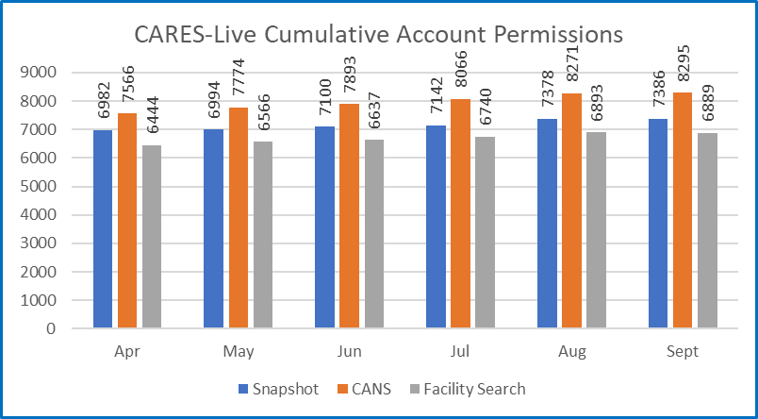

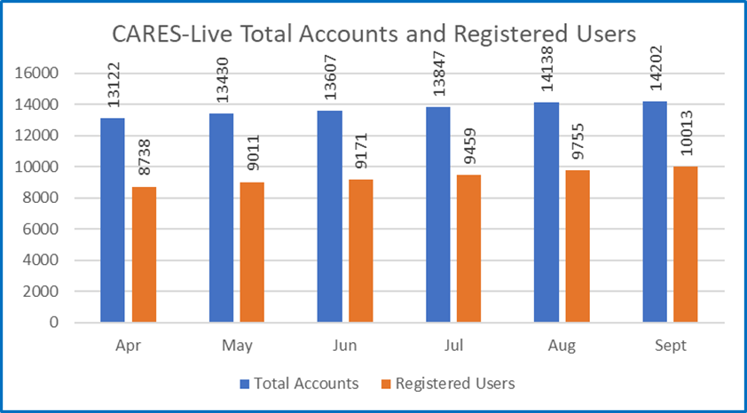

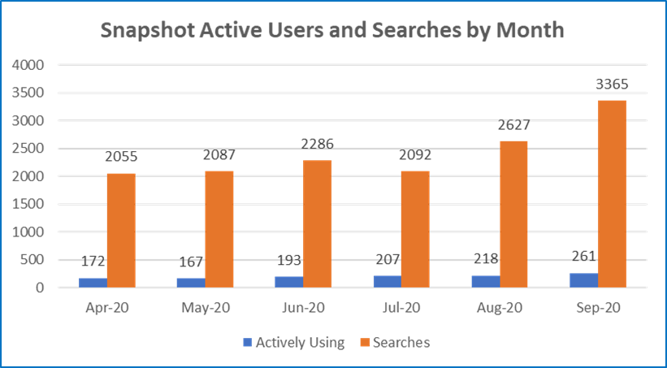

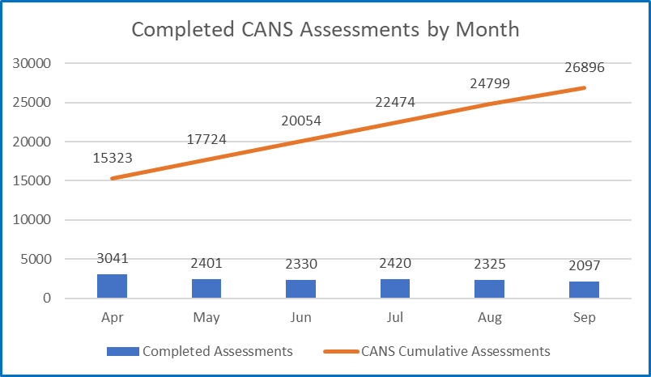

STAFFING VACANCY
Current Vacancy Rate: 13%
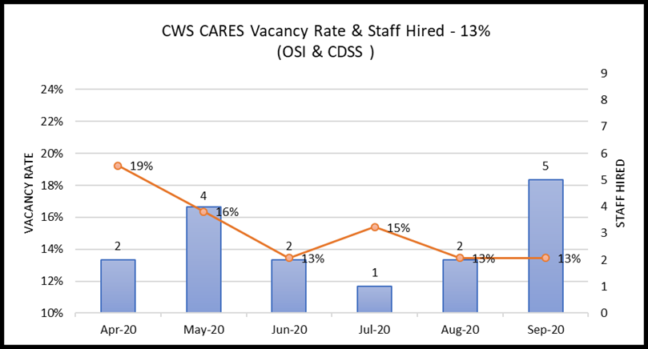
The vacancy rate remained at 13% as depicted in the graph above. There are 14 vacant position of the 104 CWS-CARES project totals. Those are depicted in the below table along with the recruitment status. Of the 14 vacancies, 9 have the Request for Personnel Action (RPA) in review with Office of System Integration (OSI) Human Resources Division.
Entity  CWS-CARES | Classification | Service Team | Date Vacant | # of Days  Vacant | Status
OSI | Information Technology Associate | Developer | 7/8/2017 | 1181 | RPA
OSI | Information Technology Associate | Project Management Office Analyst | 9/14/2020 | 17 | RPA
OSI | Information Technology Specialist I | Application Developer | 7/19/2017 | 1170 | Strategic Hold
OSI | Information Technology Specialist I | Configuration Analyst | 7/30/2019 | 429 | Tentative Offer Made
OSI | Information Technology Specialist I | Information Security Analyst | 12/4/2019 | 302 | RPA
OSI | Information Technology Specialist I | Developer / Data Scientist | 1/31/2020 | 244 | RPA
OSI | Information Technology Specialist I | Customer Relations | 8/31/2020 | 31 | RPA
OSI | Information Technology Specialist I | Information Security Analyst | 10/1/2020 | 0 | RPA
OSI | Information Technology Specialist II | DevOps Engineering | 7/31/2017 | 1158 | RPA / Re-advertisement
OSI | Information Technology Specialist II | Application Architect | 8/9/2017 | 1149 | Strategic Hold
OSI | Information Technology Specialist II | Information Security Analyst | 9/14/2019 | 383 | RPA
OSI | Information Technology Supervisor II | Product Delivery Supervisor | 8/1/2019 | 427 | Interviewing / Screening
OSI | Office Technician (Typing) | Administrative Services | 9/14/2020 | 17 | RPA
CDSS | Staff Services Manager I | Data/Business Requirements Unit | 9/21/2020 | 10 | RPA

Filled Positions
Entity  CWS-CARES | Classification | Service Team | Date Vacant | # of Days  Vacant | Efforts/Notes
OSI | Information Technology Specialist I | Product Delivery Lead | 8/20/2019 | 408 | Position Filled; Start Date of 10/1/2020
OSI | Information Technology Specialist I | Project Management Office Analyst | 1/19/2020 | 236 | Position Filled; Start Date of 9/11/2020
OSI | Information Technology Specialist I | Vendor Contract Management Analyst | 7/22/2020 | 71 | Position Filled; Start Date of 10/1/2020
OSI | Information Technology Specialist I | Project Management Office Analyst | 8/15/2020 | 31 | Position Filled; Start Date of 9/15/2020
OSI | Information Technology Supervisor II | Customer Relations Supervisor | 1/16/2020 | 229 | Position Filled; Start Date of 9/1/2020

RISKS
For the October reporting period, there are two High Priority risks open. One High Priority risk was downgraded to Medium and one High Priority risk was downgraded to Low, thus removing these two risks from this report. No new risks were added for this reporting period. No High Priority risks were closed. The below table provides details for each risk being actively managed by the PMO.

Continued Risks
Continued Risks | Impact | Resolution
Vendor Management and Coordination  RI-154  Description:  The coordination and mutual dependency in developing CARES requires higher degree of vendor management (PVS, PaaS, IS and CDI) that the Project needs to address. The Project needs to develop a plan and methodology of how we will manage the work and communication across the development of the PaaS solution. | Without an effective vendor management plan, issues will develop that will adversely affect project schedule, scope and cost. Close coordination is required between the four major components of CWS-CARES (CARES application, CDI, Data Conversion, County Implementation). | The Project will develop a new Vendor Management Plan and host the vendor management training session for all state managers.  Progress as of October 15, 2020:  Training for state managers on the vendor management process began in September and will continue through the month of Nov 2020 to include newly hired managers.

ISSUES
For the October reporting period, there are no High Priority issues open. One High Priority issue was downgraded to Medium, thus removing it from this report. No new issues were added for this reporting period. One High Priority issue was closed. The below table provides details for the closed issue.

Closed Issues
Closed Issues | Impact | Resolution
Lack of Enterprise Director to complete Enterprise System Design RI-176  Description:  Lack of Enterprise Architect to complete Enterprise System Design. The OSI CTO announced that they would be leaving the CARES project on 8/28/20, and the OSI Project Director would be naming a replacement in the coming weeks. The OSI CTO played an essential role in developing the CARES PaaS solution and led the design of the system. The project would be without a CTO, who was also the Enterprise Architect, providing critical technical direction to the project staff. The project is still in the planning stage, and technical direction and advice must be available to the technical leads to ensure the project progresses in the right direction. | The OSI CTO played an essential role in developing the CARES PaaS solution and led the design of the system. The project would be without a CTO, who was also the Enterprise Architect, providing critical technical direction to the project staff. The project is still in the planning stage, and technical direction and advice must be available to the technical leads to ensure the project progresses in the right direction. | The Project should consider performing knowledge transfer for any critical staff that plans on leaving the project. The knowledge transfer will provide the replacement or interim staff backfilling some knowledge and the understanding of the tasks accomplished and remaining tasks yet to be performed. The project may not be able to depend on the CTO’s assistance, due to the CTO’s new obligations and new tasks in their new position (with CDSS). The role of the CTO or Enterprise Architect should be filled without too long of a delay (30-45 days) at most to contribute to the completions of the Enterprise System Architecture  Status as of October 15, 2020:  This position was filled on 10/6/20.

BUDGET/EXPENDITURES
as of October 15, 2020

2019-20 CWS-CARES Budget/Expenditure Report Summary
(Footnotes below)
OSI Spending Authority Budget Item | 2019-20 Budget¹ | Actual Expenditures
Personal Services* | $9,935,256 | $7,755,050
Other OE&E** | $6,310,192 | $3,257,163
Data Center Services** | $4,000,000 | $2,837,761
Contract Services** | $13,079,372 | $10,512,131
Enterprise Services* | $4,464,544 | $4,500,309
OSI Spending Authority Total | $37,789,364 | $28,862,413

CDSS Local Assistance Budget Item | 2019-20Budget | Actual Expenditures
Contract Services*** | $522,180 | $724,528
Other OE&E*** | - | -
County Participation Costs*** | $3,221,600 | $1,746,177
CDSS Local Assistance Total | $3,743,780 | $2,470,705

CDSS State Operations Budget Item | 2019-20Budget | Actual Expenditures
Personal Services**** | $1,930,359 | $1,347,107
Facilities**** | $568,000 | $387,516
Other OE&E**** | $224,497 | $1,148,642
CDSS State Operations Total | $2,722,856 | $2,883,265

Project Totals | 2019-20 Budget | Actual Expenditures
CWS-CARES Project Total | $44,256,000 | $34,216,383

Budget/Expenditures Footnotes:
1 2019-20 Budget reflects amount in approved Special Project Report 3, plus BL Adjustments 19-24 and 19-29
* Actuals through July 2020 per FI$Cal Report
** Actuals from June 2020 FI$Cal Reports, in addition to processed invoices through October 13, 2020
*** Actuals from CDSS as of June 2020
**** Actuals through June 2020 CDSS FI$Cal Report
Questions? Email CWDS Communications: comms@cwds.ca.gov

Contingent upon ACYF approval
Contingent upon ACYF approval
Data through September 30, 2020.
Data through September 30, 2020.
Personal Services expenditures have been updated to reflect the recent Fi$Cal adjustments and subsequent updated cost allocation. Facilities and Other OE&E in review until CWS-CARES costs can be isolated.

