May 16, 2020 through June 15, 2020

VISION STATEMENT
“We will establish and maintain an innovative statewide 21st century information technology application that aids child welfare stakeholders in assuring the safety, permanency, and well-being of children at risk of abuse and neglect.”
Child Welfare Digital Services (CWDS) is a collaboration of California State and local government agencies that support our shared stakeholders through technology to assure the safety, permanency and well-being of children at risk of abuse, neglect or exploitation. CWDS is responsible for maintaining and operating the existing Child Welfare Services / Case Management System (CWS/CMS) and the development of the Child Welfare Services – California Automated Response and Engagement System (CWS-CARES). We are dedicated to building a child welfare information system that responds to users’ needs while maintaining the best standards for security and data integrity to aid child welfare professionals in the vital assistance, oversight and case management of our most vulnerable populations.

HIGHLIGHTS
During this reporting period, the Project received procurement exemption approvals for FY 2019/20 from the California Health and Human Services (CHHS) Agency that will allow CWDS to continue providing ongoing support for the legacy system (CWS/CMS) as well as for the replacement system, CARES. Project leadership is also in the process of assessing the CWS-CARES Project timeline and budget estimates for inclusion in the Special Project Report (SPR) 4 and the Implementation Advance Planning Document (IAPD). In the interim, the Project will submit an As-Needed APD to Administration on Children, Youth and Families (ACYF) to request an extension of time for the planning phase through August 30, 2020.

The Project is developing the SPR 4, which is due to the California Department of Technology (CDT) on July 20, 2020. In addition, the Project is collaborating with the CDT Independent Project Oversight (IPO) to establish new quarterly reporting per Special Project Report (SPR) 3 Condition for Approval. The first quarterly report is planned for formal submission to CDT in October 2020.

The Project’s planning efforts for the design and configuration of CARES operational applications on Salesforce continue with evaluations and negotiation planning for the essential procurements underway during the month of June. The Project anticipates the first vendor, Product Value Services (PVS), onboarding in the month of September. The CARES team is in the process of developing a vendor management training plan which will describe the tactical training process to execute the vendor management strategy. The Project anticipates completing the first phase of training in August, prior to Salesforce Integration Services vendor onboarding in September.

In addition, the Product Development team has produced a working prototype for the first screening building blocks using Salesforce limited-term licenses and continued to refine tactical guides, playbooks as well as models for relationships and households. The Project facilitated ongoing visioning sessions with tribes to better define how key Indian Child Welfare Act (ICWA) concepts such as notice and active efforts factor into the product blueprint. The Project has also conducted four ICWA consultative sessions including CDSS partners and plans to continue them every other week into September.

The Project successfully completed the development phase of the CARES-Live Training Environment. The training environment was piloted with the CWDS County Consultants and Los Angeles County to confirm the training environment and the data was working as intended prior to statewide rollout. The CARES-Live training environment service offering was sent to counties on June 30, 2020. Statewide rollout of the training environment will begin on July 15, 2020.

KEY PROJECT MILESTONES
Milestone | Planned Finish Date | Actual Finish Date | Status | Notes
Special Project Report 3 (SPR 3) Submission | 11/30/19 | 02/07/20 | Completed | On February 28, 2020, CDT approved the Special Project Report (SPR) 3 with a set of five conditions.
Salesforce Integration Services Solicitation Release | 12/11/19 | 11/07/19 | Completed | The Salesforce Integration Services Solicitation was released ahead of schedule on 11/7/2019.
Quarterly Updates to Roadmaps  (FY 2019/20 Q3) | 01/02/20 | 02/07/20 | Completed | The updated Product and Project Roadmaps were submitted with the updated SPR 3 on 2/7/2020.
Decision on Continuation of CARES-Live | 01/30/20 | 02/20/20 | Completed | The Project released three product feature-sets to date: CANS, Facility and Snapshot. The Project completed the assessment and recommendation to maintain CARES-Live to present to the BOD in February.
Data Conversion Plan Drafted | 03/30/20 | 03/22/20 | Completed | The draft plan was completed on 3/22/2020 and was reviewed with ELT on 3/30/2020. The Project team will continue to refine the plan, pending input from critical vendors, once those are onboarded in late fall.
Product Values Services (PVS) Solicitation Release | 03/17/20 | 02/05/20 | Completed | The PVS Solicitation was released ahead of schedule on 2/5/2020, with offers initially due on 4/1/2020. The offer due date, however, was delayed due to vendor questions that required responses, and the request for a one-week extension was granted due to the COVID-19 pandemic.
CDI Solicitation Release | 03/27/20 |  | In Progress | The solicitation is anticipated for release in late June.
PaaS Licenses Subscription Solicitation Release | 03/30/20 |  | In Progress | The Project procured Limited Term licenses during the planning phase for training and discovery purposes. This procurement is strategically delayed to July 2020.
Governance Plan Update Complete | 04/01/20 |  | In Progress | The updated Governance Plan was reviewed by CDT IPO and by the Executive Leadership Team (ELT). This plan requires approval by the Board of Directors (BOD).
Implementation Advance Planning Document Submitted to ACYF | 04/01/20 |  | In Progress | The IAPD draft was shared with ACYF in March 2020. The formal submission was initially delayed from April 1 to May 1, 2020 to finalize details related to budgets, procurements and critical project plans, as well as to address feedback from ACYF. Due to State budget shortfalls and the ongoing Project timeline and budget assessment(s), formal submission of the IAPD will be further delayed.
Quarterly Updates to Roadmaps  (FY 2019/20 Q4) | 04/02/20 |  | In Progress | The updated Product and Project Roadmaps were completed for inclusion in the IAPD. Upon formal submission of the IAPD, this milestone will be marked complete.
IAPD Approved by ACYF | 05/30/20 |  |  | This milestone is delayed due to the reasons stated above.
Paas License Subscription Contract Award | 06/02/20 |  |  | Pre-procurement activities are in progress, including Statement of Work development.
PVS Contract Award | 07/20/20 |  |  | Interviews were conducted on 5/14/2020. Negotiations are scheduled to take place in July.
Salesforce Integration Services Contract Award | 08/11/20 |  | In Progress | The Solicitation is in progress, with negotiations continuing through the beginning of July.
Quarterly Updates to Roadmaps (FY 2020/21 Q1 | 09/30/20
Special Project Report 4 (SPR 4) Submission | 07/20/20 |  | In Progress | SPR 4 first draft review was initiated in mid-June; formal submission to CDT is due 7/20.
FY 2021/22 BCP Submission | 08/28/20 |  |  | Budget Change Concept was submitted to OSI Fiscal in June 2020.
CDI Contract Award | 10/02/20
Quarterly Updates to Roadmaps  (FY 2020/21 Q2) | 12/31/20
Quarterly Updates to Roadmaps  (FY 2020/21 Q3) | 03/31/21
Quarterly Updates to Roadmaps  (FY 2020/21 Q4) | 06/30/21

May 16 through June 15, 2020

CARES-LIVE RELEASE STATUS

Product Feature/Service - Progress to Date
The Project made the decision in May 2019 to pause all new development, which means that no new functionality or features will be introduced to CARES-Live. The Project, however, remains committed to maintaining the integrity of the existing CARES-Live system, with an emphasis on increasing system efficiency for all users.

Implementation Activities
Implementation Activities
- Continued to gather metrics and track county feedback to provide ELT with updates about CARES-Live implementation and adoption
- Knowledge transfer of CARES-Live M&O support activities that the Implementation Team was responsible for
- Documented processes and communicated workload that is to transition from the Implementation Team to Service Desk, Customer Relations, and CARES-Live Workgroup
Organizational Change Management
- Refined CWS-CARES Master Plan for Implementation Project charter and objectives related to future OCM and implementation of CARES Salesforce
- Further refined of the CARES Master Plan for Implementation Project schedule
- Planned for initial meetings with the chartered workgroup (CARES Master Plan for Implementation Project)
- Attended and presented at several Regional User Group meetings, Oversight Committee meeting, and Technical Advisory Committee (TAC) meeting to provide implementation and CARES-Live release updates
User Training
- Finished entering baseline data for the CARES-Live Training Environment
- Continued creation of user accounts for the CARES-Live Training Environment
- Created statewide rollout strategy for the CARES-Live Training Environment
- Prepared pilot county and internal county consultants for the Training Environment Pilot
- Continued to meet and collaborate with CDSS regarding the development of a Learning Management System

CARES-Live METRICS

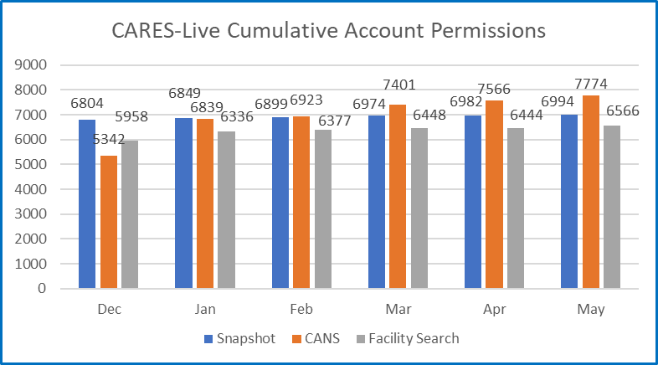

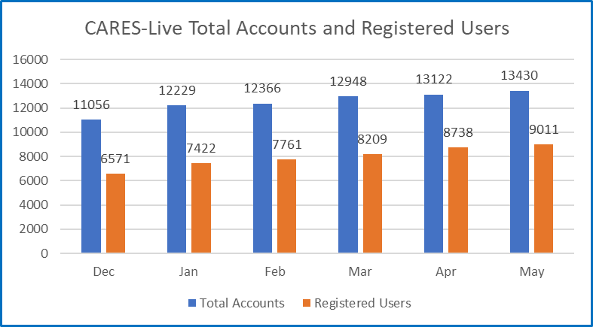

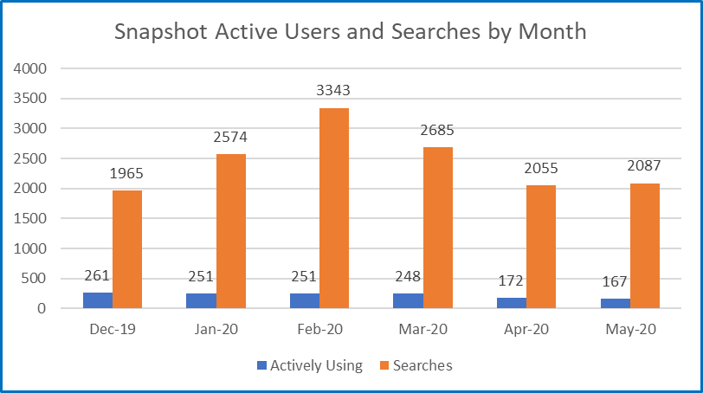

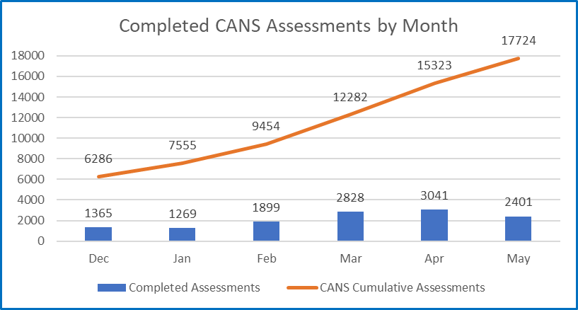

STAFFING VACANCY
Current Vacancy Rate: 15%
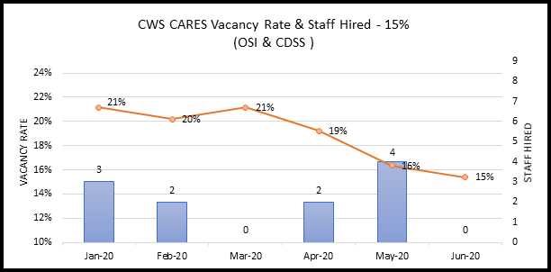
Current Vacancies - 16 of 104 CWS-CARES positions. The CWS-CARES vacancy rate has decreased from 16% since the last report.
Entity  CWS-CARES | Classification | Service Team | Date Vacant | # of Days  Vacant | Efforts/Notes
OSI | Information Technology Associate | Developer | 7/8/2017 | 1073 | Duty Statement currently under development.
OSI | Information Technology Specialist I | Product Delivery Lead | 8/20/2019 | 300 | HR – Reviewing RPA Package
OSI | Information Technology Specialist I | Product Delivery Lead | 8/1/2019 | 319 | HR – Reviewing RPA Package
OSI | Information Technology Specialist I | Project Management Office Analyst | 1/19/2020 | 148 | HR – Reviewing RPA Package
OSI | Information Technology Specialist I | Developer | 1/31/2020 | 136 | Position Planning
OSI | Information Technology Specialist I | Developer | 7/19/2017 | 1062 | Position Planning
OSI | Information Technology Specialist I | Information Security Analyst | 12/4/2019 | 194 | Position Planning  Will re-advertise once ITM I is hired.
OSI | Information Technology Specialist I | Infrastructure Analyst | 2/24/2020 | 112 | Position Planning
OSI | Information Technology Specialist I | Configuration Analyst | 7/30/2019 | 321 | Position Planning
OSI | Information Technology Manager I | Security Chief | 2/19/2020 | 117 | Start date 6/30/2020
OSI | Information Technology Specialist II | Application Architect | 8/9/2017 | 1041 | Position Planning
OSI | Information Technology Specialist II | Information Security Analyst | 9/14/2019 | 275 | Will re-advertise once ITM I is hired.
OSI | Information Technology Specialist II | DevOps Engineering | 7/31/2017 | 1050 | Currently Advertised
OSI | Staff Services Manager III | Administrative Services Unit Manager | 1/16/2020 | 151 | Reclassed to IT Sup II – Currently Advertised
CDSS | Associate Governmental Program Analyst | Licensing Program | 1/5/2018 | 892 | Position redirected to CCLD.
CDSS | Associate Governmental Program Analyst | Licensing Program | 6/28/2019 | 353 | Position redirected to CCLD.

RISKS
For this reporting period, there are three High Priority Risks. Two new High Priority risks were opened, and no risks were closed.

New Risks
New Risks | Impact | Resolution
Service Manager Leadership Effectiveness  RI-169  Description:  Service Manager roles are shared between County Consultants and CDSS Managers. Effective and timely decision making are the primary attributes of Service Managers. If Service Managers cannot carry out this responsibility, Project delivery efficiency will suffer. | Lack of clarity and experience by the Service Managers may result in slower progress than needed, in-scope disputes, or a growing amount of technical debt. | 1.) Document, socialize and reach agreement on the role of the Service Manager.  2.) Provide assistance from the Product Chief & Service Delivery Advisor  3.) ELT to monitor closely.
FCED Delay Impacts to CARES Schedule  RI-170  Description:  Foster Care Eligibility Determination (FCED) Development for CARES depends on coordinated development and deployment with CalSAWS project. The risk is that we may not be able to develop CARES within the current schedule. | Current CalSAWS schedule will delay the development work in CARES. | Conduct discussions with CalSAWS, CDSS & OSI Executive Management to confirm schedule impacts for CARES.

Continued Risks
Continued Risks | Impact | Resolution
Vendor Management and Coordination  RI-154  Description:  The coordination and mutual dependency in developing CARES requires higher degree of vendor management (PVS, PaaSIS and CDI) that the Project needs to address. The Project needs to develop a plan and methodology of how we will manage the work and communication across the development of the PaaS solution. | CARES has four major components (CARES application, CDI, Data Conversion & System Implementation) which are necessary to achieve project goals and objectives.  without an effective vendor management plan, issues will develop that will adversely affect project schedule, scope and cost. | The Project will hold a Vendor Management training on vendor management that will be delivered to all State managers by August 2020  Progress as of June 17, 2020:  Vendor Management Plan currently being updated pursuant to IPOC comments. During comment walkthrough on 6/8/20, IPOC has allowed additional time for plan to be completed, targeting VMP to be completed by mid/end June. Additionally, project is in process of developing the VMP Training Plan which will describe the tactical training process to execute the VMP strategy. VMP training must commence before 8/11/20 and be completed prior to the Salesforce IS vendor onboarding.

ISSUES
For this reporting period, there are two High Priority Issues. No new High Priority issue were opened, one issue was moved to an observation and one issue closed

Continued Issues
Continued Issues | Impact | Resolution
Lack of fully defined System Security Plan (SSP)  RI-135  Description:  CWS-CARES project lacks a fully defined Security Plan that covers all aspects of secure handling of application code and data. An SSP is the process of development but this plan for the project should be a "living document" frequently updated to include Planning, Development, and Deployment information. The lack of clearly defined security protocols, security training (which the plan would describe) is already causing some impacts to the project (through security incidents occurring after Snapshot 1.0 Release) | The lack of a defined system security plans leaves the project without clearly defined security protocols for items in production and products in the development stage and environments. | IV&V recommends that dedicated resources be allotted in developing this plan, and that the plan is reviewed by appropriate stakeholders for subsequent communication of the security controls that need to be in place for the rest of the project team members.  Status as of June 15, 2020:  Development of CARES-Live SSP is on hold pending recruitment of the Project Information Security Chief.
Lack of number of sufficient OSI Leadership staff  RI-155  Description:  The desired experience for these positions is not readily available in the state's IT workforce. Private sector experience typically provides a higher level of compensation than the state provides. | Not being able to fill these positions with staff who are sufficiently experienced to handle their roles places a workload burden on higher levels of management and puts the project at risk of sacrificing time or quality. | 1) Over the next nine months the Project needs to focus on filling the management level positions first, (ITM II, ITM I, IT SUP II)  2) Utilize one or more recruiting web sites that cast a broader net for talent than CalHR covers.  3) Redirection of existing positions into more urgent priority  4) Consider alternatives to filling positions when the positions cannot be filled.  Status as of June 15, 2020:  The Project continues to recruit for key management positions and candidates that have the desired skills and qualifications. A candidate was selected for the Security Chief during this reporting period. Other key roles on the Product team are also in active recruitment.

Closed Issues
Closed Issues | Impact | Closure Justification
Lack of technical guidance to vendors on coding practices and standards  RI-111  Description:  CWS-CARES lacks guidance on establishing coding standards and practices to the DS teams. Vendors are independently determining standards and grading their own code with no enterprise level standards to adhere to. | This may lead into a grading system for code quality that is not reliable and poor-quality product with high technical debt migrated to production. CWDS technical leadership should consider dedicating efforts to establish these standards and a mechanism to monitor adherence to these standards. | IT Ops provided revised version on Friday 6/5 based on IV&V feedback. IV&V confirmed that all outstanding items have been addressed for the CWDS CARES-Live Development Practices and Coding Standards Document. IV&V will close Findings #46, 131, and 132. No objections to closing this Risk during the 06/17/2020 Risk and Issues forum hence Risk to be closed.

BUDGET/EXPENDITURES
as of June 15, 2020

2019-20 CWS-CARES Budget/Expenditure Report Summary
(Footnotes below)
OSI Spending Authority Budget Item | 2019-20Budget¹ | Actual Expenditures
Personal Services* | $9,935,256 | $6,399,584
Other OE&E** | $6,310,192 | $2,977,033
Data Center Services** | $4,000,000 | $2,653,467
Contract Services** | $13,079,372 | $8,378,997
Enterprise Services* | $4,464,544 | $3,808,464
OSI Spending Authority Total | $37,789,364 | $24,217,545

CDSS Local Assistance Budget Item | 2019-20Budget | Actual Expenditures
Contract Services*** | $522,180 | $347,363
Other OE&E*** | - | -
County Participation Costs*** | $3,221,600 | $1,267,257
CDSS Local Assistance Total | $3,743,780 | $1,614,620

CDSS State Operations Budget Item | 2019-20Budget | Actual Expenditures
Personal Services**** | $1,930,359 | $1,093,159
Facilities**** | $568,000 | -
Other OE&E**** | $224,497 | -
CDSS State Operations Total | $2,722,856 | $1,093,159

Project Totals | 2019-20 Budget | Actual Expenditures
CWS-CARES Project Total | $44,256,000 | $26,925,324

Budget/Expenditures Footnotes:
1 2019-20 Budget reflects amount in approved Special Project Report 3, plus BL Adjustments 19-24 and 19-29
* Actuals through April 2020 per FI$Cal Report
** Actuals from April 2020 FI$Cal Reports, in addition to processed invoices through June 17, 2020
*** Actuals from CDSS as of February 2020
**** Actuals through April 2020 CDSS FI$Cal Report

Questions? Email CWDS Communications: comms@cwds.ca.gov

Data through May 31, 2020.
Data through June 15, 2020.
Personal Services expenditures have been updated to reflect the recent Fi$Cal adjustments and subsequent updated cost allocation. Facilities and Other OE&E in review until CWS-CARES costs can be isolated.

