*March 16, 2020 through**April 15, 2020*

## VISION STATEMENT

*“We will establish and maintain an innovative statewide 21st century information technology application that aids child welfare stakeholders in assuring the safety, permanency, and well-being of children at risk of abuse and neglect.”*

Child Welfare Digital Services (CWDS) is a collaboration of California State and local government agencies that support our shared stakeholders through technology to assure the safety, permanency and well-being of children at risk of abuse, neglect or exploitation. CWDS is responsible for maintaining and operating the existing Child Welfare Services / Case Management System (CWS/CMS) and the development of the Child Welfare Services – California Automated Response and Engagement System (CWS-CARES). We are dedicated to building a child welfare information system that responds to users’ needs while maintaining the best standards for security and data integrity to aid child welfare professionals in the vital assistance, oversight and case management of our most vulnerable populations.

## HIGHLIGHTS

CWDS continues to make progress towards planned project milestones in preparation of onboarding the new vendors this summer. The procurements for these vendors are in progress, which consist of key critical resources for design and configuration of the CARES operational applications on the Salesforce platform. These procurements include Salesforce integration services, software licenses, and service contracts that provide business, technical, and project advisory services. The Project is also preparing for the CWS-CARES data services, an integral component of California’s Comprehensive Child Welfare Information System (CCWIS), on the CARES Data Infrastructure (CDI). The team continues to work on the CDI solicitation, which will enable the State to maintain its own copy of all data contained within the Salesforce database, along with immutable longitudinal data on the CDI. The CDI will satisfy the State’s requirement to maintain ownership and control of child welfare data as a vital asset. For further details regarding these procurements, please see reference the Key Project Milestones table below.

To manage the vendors and help lead the efforts of the CARES Service Delivery Lifecycle, key State leadership roles are in the process of being filled in order to achieve a more structured and effective vendor management model. Filling such positions has been a challenge in the past, so various recruitment methods are being employed (e.g., targeted recruitment websites) to cast a wider net for attracting experienced talent with the required skillsets, thereby increasing the qualified candidate pool. In parallel to the procurement and State staff recruitment activities, the existing project team is utilizing the Salesforce limited-term licenses to inform how Salesforce will be configured while further refining the Product Blueprint and Product Roadmap. Using the limited-term licenses, the product delivery team is engaging in a “Test Dive” for the first building block of Screening. The main goals of the Test Dive are to gather prototype ideas to get the most out of the upcoming Salesforce Training, to get in-depth experience prototyping, demonstrate translating discovery artifacts into deep dive artifacts, and demonstrate working together intensively as a team.

In addition, the CWS-CARES Implementation Advance Planning Document (IAPD) draft was shared with Administration on Children, Youth and Families (ACYF) in March, and initial feedback was provided in early April with suggested topics that required clarification and/or more information. The Project will address this feedback in the second draft submission in April. This draft will also include key project plan attachments, which will help our stakeholders understand the overall project approach to developing the operational applications on the Salesforce platform. The goal of all the project plans is to ensure the team operates in alignment with the Project’s strategy and focus on the development of CARES and establishment of the CDI. Formal submission of the IAPD to ACYF is due May 1, 2020.

The Project also continues to work closely with other critical stakeholders, as we are in collaboration with the California Department of Technology (CDT) Independent Project Oversight (IPO) to develop appropriate measurement vehicles to assess progress on each of the five conditions placed upon the Project upon approval of Special Project Report (SPR) 3 in February 2020.

Despite the Novel Coronavirus (COVID-19) pandemic and telework transition, the CWS-CARES Project continues to achieve progress towards project milestones. The Project also continues to offer support to its partners and stakeholders, such as offering remote CARES-Live County demos upon request.

## KEY PROJECT MILESTONES

| **Milestone** | **Planned Finish Date** | **Actual Finish Date** | **Status** | **Notes** |
| --- | --- | --- | --- | --- |
| Special Project Report 3 (SPR 3) Submission | 11/30/19 | 02/07/20 | Completed | On February 28, 2020, CDT approved the Special Project Report (SPR) 3 with a set of five conditions. |
| Salesforce Integration Services Solicitation Release | 12/11/19 | 11/07/19 | Completed | The Salesforce Integration Services Solicitation was released ahead of schedule on 11/7/2019. |
| Quarterly Updates to Roadmaps  (FY 2019/20 Q3) | 01/02/20 | 02/07/20 | Completed | The updated Product and Project Roadmaps were submitted with the updated SPR 3 on 2/7/2020. |
| Decision on Continuation of CARES-Live | 01/30/20 | 02/20/20 | Completed | The Project released three product feature-sets to date: CANS, Facility and Snapshot. The Project completed the assessment and recommendation to maintain CARES-Live to present to the BOD in February. |
| Data Conversion Plan Drafted | 03/30/20 | 03/22/20 | Completed | The draft plan was completed on 3/22/2020 and was reviewed with ELT on 3/30/2020. The Project team will continue to refine the plan, pending input from critical vendors, once those are onboarded in late fall |
| Product Values Services (PVS) Solicitation Release | 03/17/20 | 02/05/20 | Completed | The PVS Solicitation was released ahead of schedule on 2/5/2020, with offers initially due on 4/1/2020. The offer due date, however, was delayed due to vendor questions that required responses, and the request for a one-week extension was granted due to the COVID-19 pandemic. . |
| CDI Solicitation Release | 03/27/20 |  | In Progress | The team is updating the Statement of Work for the CDI Solicitation based on the feedback received from the vendors during the pre-solicitation process. |
| PaaS Licenses Subscription Solicitation Release | 03/30/20 |  | In Progress | The Project procured Limited Term licenses during the planning phase for training and discovery purposes. This procurement is strategically delayed to July 2020. |
| Governance Plan Update Complete | 04/01/20 |  | In Progress | The Governance Plan was updated and reviewed by the Independent Project Oversight (IPO) and ELT. The next step is to share the Plan with the Board of Directors (BOD) for approval in May. |
| Implementation Advance Planning Document Submitted to ACYF | 04/01/20 |  | In Progress | The Implementation APD (IAPD) draft was shared with ACYF in March 2020. The formal submission of the IAPD was delayed from April 1 to May 1, 2020 to finalize details related to budgets, procurements and critical project plans, as well as address feedback from ACYF. |
| Quarterly Updates to Roadmaps  (FY 2019/20 Q4) | 04/02/20 |  | In Progress | The updated Product and Project Roadmaps were completed for inclusion in the IAPD. Upon formal submission of the IAPD in May, this milestone will be marked complete. |
| IAPD Approved by ACYF | 05/30/20 |  |  | The Project has federal funding through 6/30/2020 per the Planning APD; it is anticipated that the IAPD will not be approved until 6/30/2020. |
| Paas License Subscription Contract Award | 06/02/20 |  |  | The Solicitation is in progress. |
| PVS Contract Award | 07/20/20 |  |  | Interviews are scheduled for May 11 and 12. |
| Salesforce Integration Services Contract Award | 08/11/20 |  | In Progress | The Solicitation is in progress, negotiations are scheduled to commence 5/13/2020. |
| Quarterly Updates to Roadmaps (FY 2020/21 Q1 | 09/30/20 |  |  |  |
| Special Project Report 4 (SPR 4) Submission | 07/20/20 |  |  | In progress. |
| FY 2021/22 BCP Submission | 08/28/20 |  |  | BCC is due to OSI Fiscal in June 2020. |
| CDI Contract Award | 10/02/20 |  |  |  |
| Quarterly Updates to Roadmaps  (FY 2020/21 Q2) | 12/31/20 |  |  |  |
| Quarterly Updates to Roadmaps  (FY 2020/21 Q3) | 03/31/21 |  |  |  |
| Quarterly Updates to Roadmaps  (FY 2020/21 Q4) | 06/30/21 |  |  |  |

## March 16 through April 15, 2020

## CARES-LIVE RELEASE STATUS

### Product Feature/Service - Progress to Date

The Project made the decision in May 2019 to pause all new development, which means that no new functionality or features will be introduced to CARES-Live. The Project, however, remains committed to maintaining the integrity of the existing CARES-Live system, with an emphasis on increasing system efficiency for all users.

### CARES-Live Implementation Activities

**Implementation Activities**

* Continued to gather metrics and track county feedback to provide ELT with updates about CARES-Live implementation and adoption
* Matured CARES-Live metrics to identify feature usage at the county level
* Further refined roles and responsibilities related to CARES-Live demonstrations to improve updates and track the value of demos
* Decided to limit contact with counties regarding implementation and adoption due to COVID-19 to allow counties to focus on their essential functions

**Organizational Change Management**

* Continued identifying high-level vision and objectives related to future OCM and implementation of CARES-Live
* Attended several Regional User Group meetings, Oversight, and Technical Advisory Committee (TAC) to provide implementation and CARES-Live release updates

**User Training**

* Identified and implemented a process to create county-level data for the CARES-Live Training Environment
* Performed data cleansing of the existing data in the CARES-Live Training Environment
* Finalized support model for the CARES-Live Training Environment
* Refined schedule for the CARES-Live Training Environment
* Identified how to make a subset of training material more accessible to users on the Implementation Portal

## CARES-Live METRICS[1]

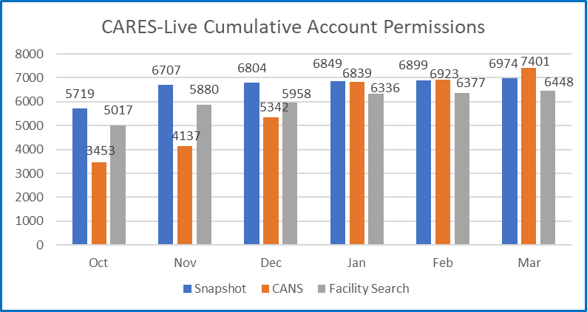

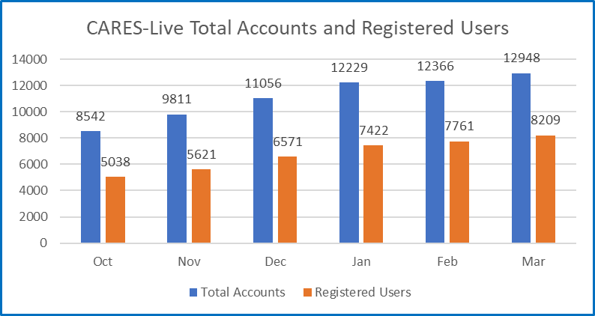

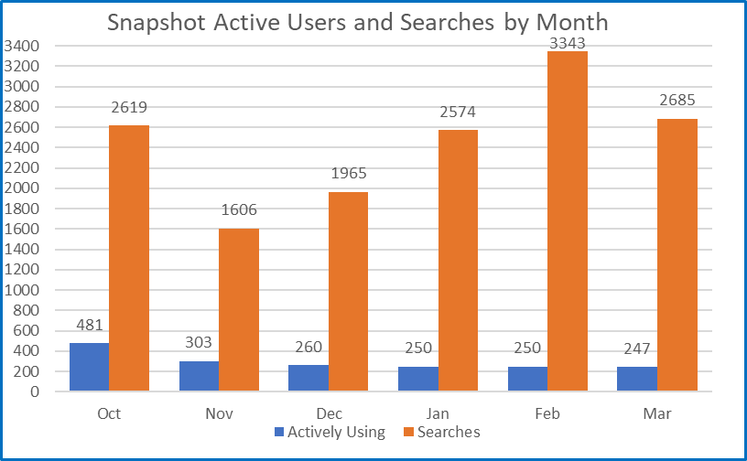

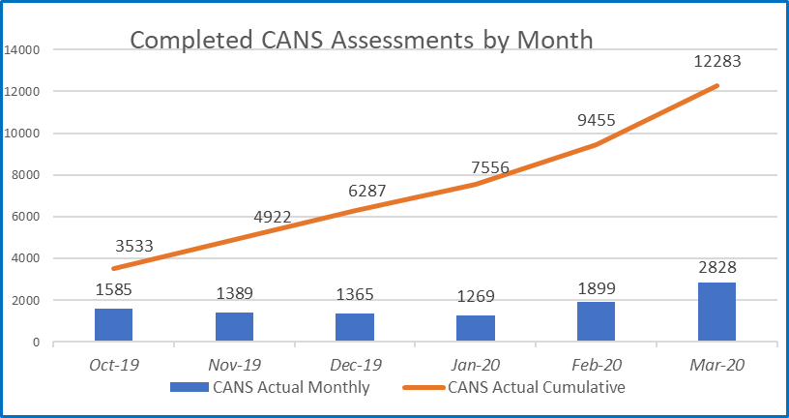

**STAFFING VACANCY[2]**

Current Vacancy Rate: 19%

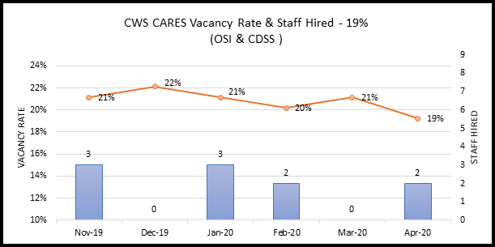

Current Vacancies - 20 of 104 CWS-CARES positions. The CWS-CARES vacancy rate has decreased from 21% since the last report.

| **Entity CWS-CARES** | **Classification** | **Service Team** | **Date Vacant** | **# of Days**  **Vacant** | **Efforts/Notes** |
| --- | --- | --- | --- | --- | --- |
| OSI | Information Technology Associate | Developer | 7/8/2017 | 1012 | Duty Statement currently under development. |
| OSI | Information Technology Associate | Implementation Team Member | 1/12/2020 | 94 | Interview results are currently being scored. |
| OSI | Information Technology Associate | Procurement and Contract Management Analyst | 11/27/2019 | 140 | Screening of applicants in progress. |
| OSI | Information Technology Specialist I | Product Delivery Lead | 8/20/2019 | 239 | Duty Statement currently under development. |
| OSI | Information Technology Specialist I | Product Delivery Lead | 8/1/2019 | 258 | Duty Statement currently under development. |
| OSI | Information Technology Specialist I | Project Management Office Analyst | 1/19/2020 | 87 | Duty Statement currently under development. |
| OSI | Information Technology Specialist I | Developer | 1/31/2020 | 75 | HR is reviewing RPA package. |
| OSI | Information Technology Specialist I | Developer | 7/19/2017 | 1001 | Duty Statement currently under development. |
| OSI | Information Technology Specialist I | Information Security Analyst | 12/4/2019 | 133 | Will re-advertise once ITM I is hired. |
| OSI | Information Technology Specialist I | Infrastructure Analyst | 2/24/2020 | 51 | Duty Statement currently under development. |
| OSI | Information Technology Specialist I | Configuration Analyst | 7/30/2019 | 260 | No candidate selected - will re-advertise. |
| OSI | Information Technology Supervisor II | Data Management | 8/2/2017 | 987 | Duty Statement currently under development. |
| OSI | Information Technology Manager I | Product Chief | 7/28/2017 | 992 | HR approved hire of candidate - start date tbd. |
| OSI | Information Technology Manager I | Security Chief | 2/19/2020 | 56 | Screening of applicants in progress. |
| OSI | Information Technology Specialist II | Application Architect | 8/9/2017 | 980 | Duty Statement currently under development. |
| OSI | Information Technology Specialist II | Information Security Analyst | 9/14/2019 | 214 | Will re-advertise once ITM I is hired. |
| OSI | Information Technology Specialist II | DevOps Engineering | 7/31/2017 | 989 | No candidate selected - will re-advertise. |
| OSI | Staff Services Manager III | Administrative Services Unit Manager | 1/16/2020 | 90 | Duty Statement currently under development. |
| CDSS | Associate Governmental Program Analyst | Licensing Program | 1/5/2018 | 831 | Position on strategic hold. |
| CDSS | Associate Governmental Program Analyst | Licensing Program | 6/28/2019 | 292 | Position on strategic hold. |

Filled Positions

| **Entity CWS-CARES** | **Classification** | **Service Team** | **Date Vacant** | **# of Days**  **Vacant** | **Efforts/Notes** |
| --- | --- | --- | --- | --- | --- |
| OSI | Information Technology Specialist I | Developer | 7/1/2017 | 1005 | Official start date of 4/1/2020 |
| CDSS | Information Technology Specialist I | Licensing Program Specialist | 7/12/2019 | 264 | Official start date of 4/1/2020. |

## RISKS

For this reporting period, there is one High Priority Risks. No new High Priority risks were opened and one risk was closed.

### Continued Risks

| **Continued Risks** | **Impact** | **Resolution** |
| --- | --- | --- |
| **Vendor Management and Coordination**  **RI-154**  *Description:*  *The coordination and mutual dependency in developing CARES requires higher degree of vendor management (PVS, PaaSIS and CDI) that the Project needs to address. The Project needs to develop a plan and methodology of how we will manage the work and communication across the development of the PaaS solution.* | CARES has four major components (CARES application, CDI, Data Conversion & System Implementation) which are necessary to achieve project goals and objectives.  without an effective vendor management plan, issues will develop that will adversely affect project schedule, scope and cost. | The Project will hold a Vendor Management training on vendor management that will be delivered to all State managers by August 2020  *Progress as of April 15, 2020:*  *With the approval of the SPR 3, there was a condition specific to this risk. A vendor management plan is being developed in response to the SPR 3 condition. Additionally, each State Functional Manager will have a dedicated Procurements & Contract Management (PCM) contract analyst to assist with Work Order Authorization (WOA) process.* |

### Closed Risks

| **Closed Risks** | **Impact** | **Closure Justification** |
| --- | --- | --- |
| **Lack of information regarding Service Level Agreements for Salesforce License Subscription**  **RI-147**  *Description:*  *If the Service Level Agreement (SLA) for the PaaS License Subscription is not completed timely, the procurement schedule to obtain these licenses will be delayed.* | The procurement of the Salesforce License Subscription may be delayed if the Project does not receive this information. This could result in the Salesforce Integration Services vendor onboarding prior to the Project procuring the Salesforce License Subscription. | Date Closed: April 6, 2020  The received SLA's for the Salesforce Licenses. These were reviewed with CDT and IPO. Closing this issue. |

## ISSUES

For this reporting period, there are four High Priority Issues. No new High Priority issue were opened, one issue was closed.

### Continued Issues

| **Continued Issues** | **Impact** | **Resolution** |
| --- | --- | --- |
| **DevOps Maturity Assessment Needed**  **RI-58**  *Description:*  *The project added four senior engineering resources to support DevOps in the completion of the delivery pipeline. However, it is unclear that the addition of these resources have made a significant impact toward reaching this goal, as the project continues to struggle with consistency across environments, environment availability, along with other technical challenges. A maturity assessment would shed light on this concern.* | Pipeline development is unclear. Continuous lack of consistency across environments and environment unavailability. | When a new Independent Verification and Validation (IV&V) contract is executed, the vendor to perform a maturity assessment within the first 30 days on the DevOps team and the delivery pipeline.  *Status as of April 15, 2020:*  *IV&V will be performing a Maturity Assessment on the DevOps section. This will set a baseline for the DevOps area. Once the assessment is completed this issue will be closed. If there are any major gaps identified, then either new risks or issues will be created. Assessment set to be completed by May 8, 2020.* |
| **Lack of technical guidance to vendors on coding practices and standards**  **RI-111**  *Description:*  *CWS-CARES lacks guidance on establishing coding standards and practices to the DS teams. Vendors are independently determining standards and grading their own code with no enterprise level standards to adhere to.* | This may lead into a grading system for code quality that is not reliable and poor-quality product with high technical debt migrated to production. CWDS technical leadership should consider dedicating efforts to establish these standards and a mechanism to monitor adherence to these standards. | CWS-CARES technical leadership must develop a clear and concise mechanism for best practices for coding and standards that need to be met to maintain a high quality of code. This should be communicated to the DS teams and monitored to verify adherence to established standards.  *Status as of April 15, 2020*  *IV&V provided a template of the format in which the coding standards should be documented. CARES-Live team is currently working on this document and estimated to be completed within 2-3 weeks. Once the document is complete, the team will send it over to IV&V for review. Once finalized, this will be published to SharePoint and will close this Issue. Scheduled completion of the report is mid-April (4/17/20). Once the document is complete, the team will send it over to IV&V for review.* |
| **Lack of fully defined System Security Plan (SSP)**  **RI-135**  *Description:*  *CWS-CARES project lacks a fully defined Security Plan that covers all aspects of secure handling of application code and data. An SSP is the process of development but this plan for the project should be a "living document" frequently updated to include Planning, Development, and Deployment information. The lack of clearly defined security protocols, security training (which the plan would describe) is already causing some impacts to the project (through security incidents occurring after Snapshot 1.0 Release)* | The lack of a defined system security plans leaves the project without clearly defined security protocols for items in production and products in the development stage and environments. | IV&V recommends that dedicated resources be allotted in developing this plan, and that the plan is reviewed by appropriate stakeholders for subsequent communication of the security controls that need to be in place for the rest of the project team members.  *Status as of April 15, 2020:*  *Development of CARES-Live SSP is on hold pending recruitment of the Project Information Security Chief.* |
| **Lack of number of sufficient OSI Leadership staff**  **RI-155**  *Description:*  *The desired experience for these positions is not readily available in the state's IT workforce. Private sector experience typically provides a higher level of compensation than the state provides.* | Not being able to fill these positions with staff who are sufficiently experienced to handle their roles places a workload burden on higher levels of management and puts the project at risk of sacrificing time or quality. | 1) Over the next nine months the Project needs to focus on filling the management level positions first, (ITM II, ITM I, IT SUP II)  2) Utilize one or more recruiting web sites that cast a broader net for talent than CalHR covers.  3) Redirection of existing positions into more urgent priority  4) Consider alternatives to filling positions when the positions cannot be filled.  *Status as of April 15, 2020:*  *A leadership position was posted, and leadership is in the process of reviewing applications***.** |

### Closed Issues

| **Closed Issues** | **Impact** | **Closure Justification** |
| --- | --- | --- |
| **Lack of Resource Overlap and Knowledge Transfer**  **RI-141**  *Description:*  *There is a risk that contracted resources will be leaving the Project prior to hiring additional staff or other contracted resources, resulting in lack of knowledge transfer.* | By losing key contracted staff without the proper knowledge transfer to either state staff or other contracted vendors could cause a delay in the schedule due to new resources having to learn on the job. This could also impact the development of the CARES-Live and CRM-based PaaS solution, as the resources may not be available to assist with the development. | Date Closed: April 6, 2020  The project on-boarded the CARES-Live Production Support Services vendors. Over 70% of the resources have already worked on the Project. |

## BUDGET/EXPENDITURES

as of april 15, 2020

**2019-20 CWS-CARES Budget/Expenditure Report Summary**

*(Footnotes below)*

| **OSI Spending Authority Budget Item** | **2019-20Budget1** | **Actual Expenditures** |
| --- | --- | --- |
| Personnel Services* | $9,935,256 | $5,113,672 |
| Other OE&E** | $6,310,192 | $2,479,204 |
| Data Center Services** | $4,000,000 | $2,153,239 |
| Contract Services** | $13,079,372 | $6,647,051 |
| Enterprise Services* | $4,464,544 | $2,753,787 |
| **OSI Spending Authority Total** | **$37,789,364** | **$19,146,953** |

| **CDSS Local Assistance Budget Item** | **2019-20Budget** | **Actual Expenditures** |
| --- | --- | --- |
| Contract Services*** | $522,180 | $347,363 |
| Other OE&E*** | - | - |
| County Participation Costs*** | $3,221,600 | 1267257 |
| **CDSS Local Assistance Total** | **$3,743,780** | **$1,614,620** |

| **CDSS State Operations Budget Item** | **2019-20Budget** | **Actual Expenditures** |
| --- | --- | --- |
| Personnel Services**** | $1,930,359 | $1,691,358 |
| Facilities**** | $568,000 | $289,253 |
| Other OE&E**** | $224,497 | $319,371 |
| **CDSS State Operations Total** | **$2,722,856** | **$2,299,982** |

| **Project Totals** | **2019-20 Budget** | **Actual Expenditures** |
| --- | --- | --- |
| **CWS-CARES Project Total** | **$44,256,000** | **$23,061,556** |

1 2019-20 Budget reflects amount in approved Special Project Report 3, plus BL Adjustments 19-24 and 19-29

* Actuals through February 2020 per FI$Cal Report

** Actuals from February 2020 FI$Cal Reports, in addition to processed invoices through April 15, 2020

*** Actuals from CDSS as of February 2020

**** Actuals through February 2020 CDSS FI$Cal Report

1. Data through March 31, 2020.
2. Data through April 10, 2020.