January 16, 2020 through February 15, 2020

VISION STATEMENT
“We will establish and maintain an innovative statewide 21st century information technology application that aids child welfare stakeholders in assuring the safety, permanency, and well-being of children at risk of abuse and neglect.”
Child Welfare Digital Services (CWDS) is a collaboration of California State and local government agencies that support our shared stakeholders through technology to assure the safety, permanency and well-being of children at risk of abuse, neglect or exploitation. CWDS is responsible for maintaining and operating the existing Child Welfare Services / Case Management System (CWS/CMS) and the development of the Child Welfare Services – California Automated Response and Engagement System (CWS-CARES). We are dedicated to building a child welfare information system that responds to users’ needs while maintaining the best standards for security and data integrity to aid child welfare professionals in the vital assistance, oversight and case management of our most vulnerable populations.

HIGHLIGHTS
During the month of January and February, the Project team focused on a report to assess the business value, usage and costs to maintain CARES-Live. This work effort is in preparation for the Board of Directors meeting on February 20, 2020, where the decision to continue support of CARES-Live in production will be made. In the meantime, the Project remains committed to maintaining the integrity of the existing CARES-Live system, with an emphasis on increasing system efficiency for all users.

As a goal of the Continuum of Care Reform, the California Department of Social Services (CDSS) and the Counties have an ongoing need to use the Child and Adolescent Needs and Strengths (CANS) data in order to evaluate the needs and services for children in foster care statewide. This need prompted a request to the CWS-CARES Project that the CANS data be provided monthly to CDSS, which will enhance program reporting for the purposes of evaluation, oversight, monitoring progress, and addressing any outstanding data needs. On January 14, a CANS data extract was successfully submitted via a secured channel specifically created for this purpose. This process was streamlined in early February by automating the data extract for delivery to CDSS at the beginning of every month.

On January 22, the Project released CARES-Live 2.8, which provided backend infrastructure enhancements and improvements to CARES-Live technical performance. On January 23, the development team detected errors associated with updated placement home records that caused inaccurate CARES-Live search results. As a result, the Project rolled back the update while retaining the other components included for development clean-up in this release. The backend infrastructure enhancements will be assessed for redeployment into production at a later date.

Significant progress has been made with regard to CARES planning efforts as well. The limited term Salesforce licenses were procured on January 31, and the project will use the licenses for discovery and training purposes during the remainder of the planning phase. Also, in early February, the Product Delivery team started Product Blueprint refinement sessions for “Courts” with the focus of elaborating and identifying major paths, decision points and key interaction points with Intake, Case Management and Licensing.

The Special Project Report 3 was formally submitted to the California Department of Technology (CDT) on February 7, 2020 for approval.
On January 28, the Administration on Children, Youth and Families (ACYF) approved the As-Needed Advance Planning Document (APD) that was submitted on January 17. The As-Needed APD includes approval to acquire key resources that will provide business, technical and project advisory services as the project transitions from the planning phase and throughout implementation. The APD also included approval for the limited term Salesforce licenses/subscription. The Project is in the process of developing the Implementation APD. Formal submission to ACYF is due April 1, 2020.

KEY PROJECT MILESTONES
Milestone | Planned Finish Date | Actual Finish Date | Status | Notes
Special Project Report 3 (SPR 3) Submission | 11/30/2019 | 02/07/2020 | In Progress | The SPR 3 was formally submitted to CDT on February 7, 2020 for approval.
Release CARES-Live 2.8 | 01/22/2020 | 01/22/2020 | Completed | CARES-Live 2.8 was released on January 22; however, due to errors in search results, the updated was rolled back the following day. The release was renamed Hotfix 2.8.1.
Decision on Continuation of CARES-Live | 01/2020 |  | In Progress | The Project released three CARES-Live feature-sets to date: CANS, Facility Search and Snapshot. The Project completed the assessment of the costs and benefits of continuing to support CARES-Live, for review by the BOD in February.
Implementation Advance Planning Document Submitted to ACYF | 04/01/2020 |  | In Progress | The Implementation APD (IAPD) is in development.
Salesforce Integration Services Procurement | 08/11/2020 |  | In Progress | The Solicitation is in progress.
Salesforce License Procurement | 06/02/2020 |  | In Progress | The Project is collaborating with CDT STP to develop the solicitation. In the interim, the Project procured limited term licenses for training and planning purposes.
CARES Data Infrastructure Procurement | 10/02/2020 |  | In Progress | ACYF approved the CDI solicitation for release; a pre-solicitation will be released in early March.
Product Value Services Procurement | 04/16/2020 |  | In Progress | The Solicitation was released on February 5, 2020. Bids are due on March 11, 2020.

January 16 through February 15, 2020

CARES-LIVE RELEASE STATUS

Product Feature/Service - Progress to Date
The Project made the decision in May 2019 to pause all new development, which means that no new functionality or features will be introduced to CARES-Live. The Project, however, remains committed to maintaining the integrity of the existing CARES-Live system, with an emphasis on increasing system efficiency for all users.

CARES-Live Release 2.8
CARES-Live 2.8 Enhancements:
The purpose of this release is to improve CARES-Live technical performance, and includes the following:
- Increase Service Level Agreements attainment of 10 second replication time closer to 100%. Average replication will likely be less than two (2) seconds and all outliers should be eliminated
- Reduce mainframe CPU usage by as much as 50%
- Reduce the likelihood of intermittent outages and resource usage spikes

CARES-Live Implementation Activities
Implementation Activities
- Conducted ad-hoc bulk user load request. Continued to offer bulk user loading for child welfare, probation, and CDSS, to provide access to one or all of the CARES-Live feature sets: Snapshot, CANS and Facility Search
- Continued to gather metrics and track county feedback to provide ELT with weekly updates about CARES-Live implementation and adoption
- Started a CARES-Live adoption campaign which entails a 6-part questionnaire to child welfare, probation, and CDSS to gauge successes and barriers to implementation and adoption
Organizational Change Management
- Attended several Regional User Group meetings, Oversight, and Technical Advisory Committee (TAC) to provide implementation and release updates
User Training
- Participated in discussions and facilitated next steps for the Training Environment regarding user access, data creation, data validation, data cleansing, and user access
- Followed up on next steps for the Training Environment
- Reviewed mock target data for the Training Environment
- Reviewed the entry of baseline data into the Training Environment

CARES-Live METRICS

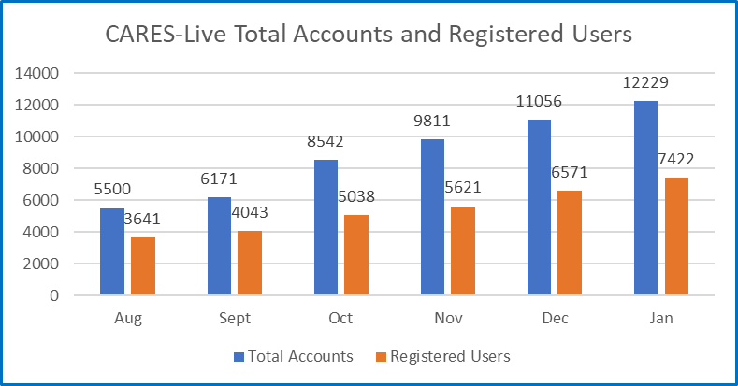

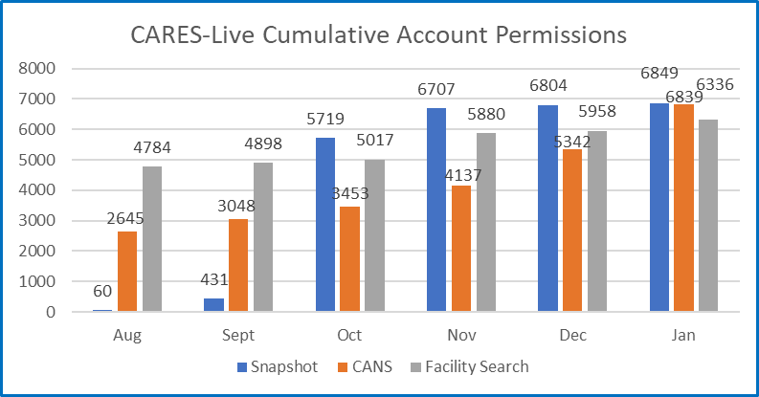

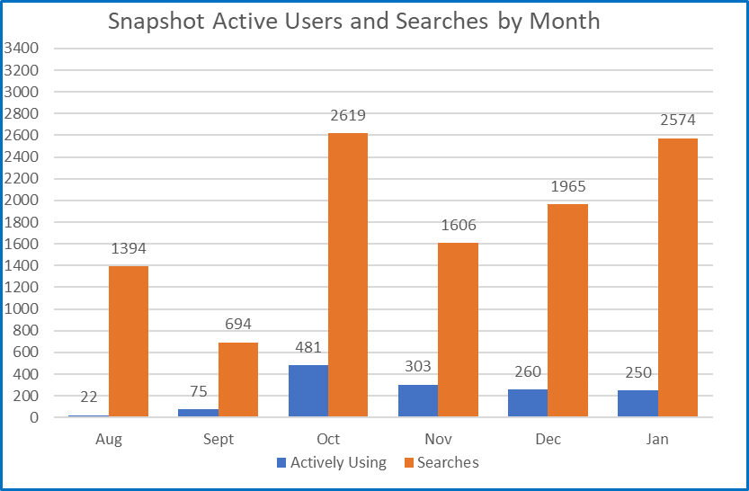
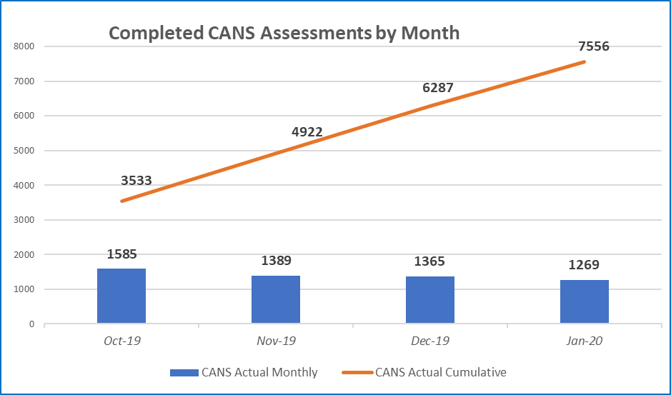

STAFFING VACANCY
Current Vacancy Rate: 18%
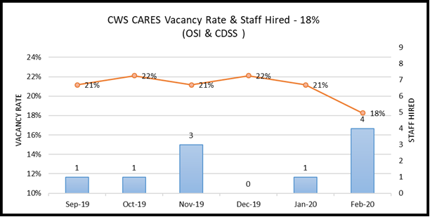
Current Vacancies - 19 of 104 CWS-CARES positions. The vacancy rate decreased from 21% to 18% since the last report.
Entity  CWS-CARES | Classification | Service Team | Date Vacant | # of Days  Vacant | Efforts/Notes
OSI | Associate Governmental Program Analyst | Procurement and Contract Management Analyst | 11/27/2019 | 80 | This position will be filled as an Information Technology Association; RPA is with OSI HR
OSI | Information Technology Associate | Developer | 7/1/2017 | 959 | Position on strategic hold
OSI | Information Technology Associate | Implementation Team Member | 1/12/2020 | 34 | RPA under construction
OSI | Information Technology Manager I | Product Chief | 7/1/2017 | 959 | Position posted; final filing date is 02/16/20
OSI | Information Technology Specialist I | Developer | 7/1/2017 | 959 | RPA under construction
OSI | Information Technology Specialist I | Developer | 7/1/2017 | 959 | Position on strategic hold
OSI | Information Technology Specialist I | Configuration Analyst | 7/1/2019 | 229 | RPA and Duty Statement under development
OSI | Information Technology Specialist I | Product Delivery Lead | 8/1/2019 | 198 | Position on strategic hold
OSI | Information Technology Specialist I | Product Delivery Lead | 8/20/2019 | 179 | Position on strategic hold
OSI | Information Technology Specialist I | Information Security Analyst | 12/4/2019 | 73 | Tentative offer sent to potential candidate
OSI | Information Technology Specialist I | Project Management Office Analyst | 1/19/2020 | 27 | Position on strategic hold
OSI | Information Technology Specialist II | DevOps Engineering | 7/1/2017 | 959 | Position will be reposted during week of 3/2/20 due to insufficient candidate pool
OSI | Information Technology Specialist II | Application Architect | 7/1/2017 | 959 | 2nd interviews completed- scoring underway-2/7/20.
OSI | Information Technology Specialist II | Information Security Analyst | 9/14/2019 | 154 | Position on strategic hold
OSI | Information Technology Supervisor II | Data Management | 7/1/2017 | 959 | Position on strategic hold
OSI | Staff Services Manager III | Administrative Services Unit Manager | 1/16/2020 | 30 | Position on strategic hold
CDSS | Associate Governmental Program Analyst | Licensing Program | 1/5/2018 | 771 | Position on strategic hold
CDSS | Associate Governmental Program Analyst | Licensing Program | 6/28/2019 | 232 | Position on strategic hold
CDSS | Information Technology Specialist I | Licensing Program Specialist | 7/12/2019 | 218 | Reposted as the candidate declined the offer; screening new application

  - Filled Positions
Entity  CWS-CARES | Classification | Service Team | Date Vacant | # of Days  Vacant | Efforts/Notes
OSI | Information Technology Specialist I | Information Security Analyst | 7/1/2017 | 944 | Formal start date 01/31/2020
OSI | Information Technology Specialist II | Jira Administrator | 9/30/2019 | 112 | Formal start date 01/20/2020
OSI | Staff Services Manager II | Financial Manager | 10/30/2019 | 96 | Formal start date 02/03/2020
OSI | Information Technology Specialist II | DevOps Engineering | 7/1/2017 | 956 | Formal start date 02/12/2020

RISKS
For this reporting period, there are four High Priority Risks. Two new High Priority risks were opened, and no risks were closed.

New Risks
New Risks | Impact | Resolution
Vendor Management and Coordination  RI-154  Description:  The coordination and mutual dependency in developing CARES requires higher degree of vendor management (PVS, PaaSIS and CDI) that the Project needs to address. The Project needs to develop a plan and methodology of how we will manage the work and communication across the development of the PaaS solution. | CARES has four major components (CARES application, CDI, Data Conversion & System Implementation) which are necessary to achieve project goals and objectives.  without an effective vendor management plan, issues will develop that will adversely affect project schedule, scope and cost. | The Project will hold a Vendor Management training on vendor management that will be delivered to all State managers by August 2020
Insufficient time allotted for penetration testing for CARES-Live  RI-160  Description:  Insufficient notification of planned penetration testing making it difficult for the team to fully complete the required work. Lack of completed testing could cause CARES-Live be released with vulnerability. | Without completed testing, any CARES-Live releases could include vulnerabilities | Create a release schedule for any future releases.  Provide 5 working days’ notice of testing need to all applicable parties.  After code freeze, allow for 2-3 working days to complete test and present any findings via Jira tickets.  Incorporate into standard CARES-Live release protocol.

Continued Risks
Continued Risks | Impact | Resolution
Lack of Resource Overlap and Knowledge Transfer  RI-141  Description:  There is a risk that contracted resources will be leaving the Project prior to hiring additional staff or other contracted resources, resulting in lack of knowledge transfer. | By losing key contracted staff without the proper knowledge transfer to either state staff or other contracted vendors could cause a delay in the schedule due to new resources having to learn on the job. This could also impact the development of the CARES-Live and CRM-based PaaS solution, as the resources may not be available to assist with the development. | *Interim resources until new vendor is on-board are identified as: Lindy Davis, David Chain, and John Simko.  *The current Oncore contract that has a few CARES-Live resources has been extended until mid-February but will not be extended further.  *Minimize or make no further modification to CARES-Live until resources are on board from the CARES-Live Support Services contract.  Progress as of 02/15/2020:  On January 27, 2020, there was an update that the CARES-Live production support services contract award date was moved to mid/late March. Until that time, there is work going on with moving resources from an expiring contract to one that has more time in order to maximize the coverage and support of CARES-Live.
Lack of information regarding Service Level Agreements for Salesforce License Subscription  RI-147  Description:  If the Service Level Agreement (SLA) for the PaaS License Subscription is not completed timely, the procurement schedule to obtain these licenses will be delayed. | The procurement of the Salesforce License Subscription may be delayed if the Project does not receive this information. This could result in the Salesforce Integration Services vendor onboarding prior to the Project procuring the Salesforce License Subscription. | Working with Risk owner on developing mitigation steps. One of these steps is working directly with Salesforce to gather the requested SLA information.  Progress as of 02/15/2020  CWDS obtained information from ACYF regarding another state who encountered similar issues. The team will follow up on that lead to gather lessons learned and guidance.

ISSUES
For this reporting period, one new High Priority issue was opened, and no issues were closed.

New Issues
New Issues | Impact | Resolution
Lack of number of sufficient OSI Leadership staff  RI-155  Description:  The desired experience for these positions is not readily available in the state's IT workforce. Private sector experience typically provides a higher level of compensation than the state provides. | Not being able to fill these positions with staff who are sufficiently experienced to handle their roles places a workload burden on higher levels of management and puts the project at risk of sacrificing time or quality. | 1) Over the next nine months the Project needs to focus on filling the management level positions first, (ITM II, ITM I, IT SUP II)  2) Utilize one or more recruiting web sites that cast a broader net for talent than CalHR covers

BUDGET/EXPENDITURES
as of February 15, 2020
2019-20 CWS-CARES Budget/Expenditure Report Summary

OSI Spending Authority  Budget Item | 2019-20 Budget¹ | Actual Expenditures | Projected Expenditures | Total Actuals/ Projections
Personnel Services* | $ 9,935,256 | $ 3,882,790 | $ 3,604,975 | $ 7,487,765
Other OE&E** | $ 7,212,493 | $ 885,353 | $ 2,253,003 | $ 3,138,357
Data Center Services** | $ 4,000,000 | $ 1,823,980 | $ 1,192,296 | $ 3,016,275
Contract Services** | $ 12,919,183 | $ 5,954,146 | $ 4,885,437 | $ 10,839,583
Enterprise Services* | $ 3,088,032 | $ 922,486 | $ 1,082,508 | $ 2,004,994
OSI Spending Authority Total | $ 37,154,964 | $ 13,468,755 | $ 13,018,220 | $ 26,486,974

CDSS Local Assistance  Budget Item | 2019-20 Budget | Actual Expenditures | Projected Expenditures | Total Actuals/ Projections
Contract Services*** | $ 522,180 | $ 292,460 | $ 201,669 | $ 494,128
Other OE&E*** | - | - | - | -
County Participation Costs*** | $ 3,200,000 | - | $ 3,200,000 | $ 3,200,000
CDSS Local Assistance Total | $ 3,722,180 | $ 292,460 | $ 3,401,669 | $ 3,694,128

CDSS State Operations  Budget Item | 2019-20 Budget | Actual Expenditures | Projected Expenditures | Total Actuals/ Projections
Personnel Services**** | $ 1,930,359 | - | $ 1,930,359 | $ 1,930,359
Facilities**** | $ 568,000 | - | $ 568,000 | $ 568,000
Other OE&E**** | $ 224,497 | - | $ 224,497 | $ 224,497
CDSS State Operations Total | $2,722,856 | - | $2,722,856 | $2,722,856

Project Totals | 2019-20 Budget | Actual Expenditures | Projected Expenditures | Total Actuals/ Projections
CWS-CARES Project Total | $ 43,600,000 | $ 13,761,214 | $ 19,142,744 | $ 32,903,958
1 2019-20 Budget reflects amount in FY 2019-20 Governor's Budget
* Actuals through December 2019 per FI$Cal Report
** Actuals from December 2019 Fi$CAL Reports, in addition to processed invoices through February 12, 2020
*** Actuals from CDSS as of January 2020
**** Actuals per CalSTARS Report (no actuals have been received for FY 2019-20 to-date)

Data through January 31, 2020.

