December 16, 2019 through January 15, 2020

VISION STATEMENT
“We will establish and maintain an innovative statewide 21st century information technology application that aids child welfare stakeholders in assuring the safety, permanency, and well-being of children at risk of abuse and neglect.”
Child Welfare Digital Services (CWDS) is a collaboration of California State and local government agencies that support our shared stakeholders through technology to assure the safety, permanency and well-being of children at risk of abuse, neglect or exploitation. CWDS is responsible for maintaining and operating the existing Child Welfare Services / Case Management System (CWS/CMS) and the development of the Child Welfare Services – California Automated Response and Engagement System (CWS-CARES). We are dedicated to building a child welfare information system that responds to users’ needs while maintaining the best standards for security and data integrity to aid child welfare professionals in the vital assistance, oversight and case management of our most vulnerable populations.

HIGHLIGHTS
On December 19, the Project released CARES-Live 2.7.2 Hotfix, which consisted of enhancements to New Relic (CARES-Live performance and usage metrics tool) to capture and report user metrics for Facility Search. Similar to the enhancements that were in the previous CARES-Live 2.7 release, these enhancements allow the Project to further understand organizational use case scenarios and determine how CWDS can better support organizations as they continue to adopt CARES-Live as part of their existing workflows. CARES-Live 2.8 is targeted for release on January 22, and this release will provide backend infrastructure improvements. Additional details regarding these releases can be found in the CARES-Live Release Status section below. Additionally, CARES-Live user adoption continues to increase as the Project continues to receive county requests to add large quantities of additional users.

The Project continues to provide CARES-Live support to stakeholders through weekly calls where feature demonstrations, county implementation successes and learning opportunities are shared in order to increase awareness and adoption of CARES-Live. In addition, the Project is offering remote and/or onsite demonstrations by request. Seven demonstrations were given to county child welfare organizations, probation and the California Department of Social Services (CDSS) during this reporting period.

Planning activities towards building CARES in the Salesforce Service Cloud are also in progress. The Product Delivery team continues to conduct planning activities for the first process area in the Product Blueprint, which is Screening. Other planning activities include the refinement of tactical guides that define roles and responsibilities and decision points in each phase of the Service Delivery Lifecycle (SDLC). Of particular importance to the successful delivery of CWS-CARES is the new Discovery Phase of the SDLC. Discovery is designed to ensure that CARES product features directly support program goals and Integrated Core Practice Model (ICPM) behaviors and generate high-quality data to inform program improvement.

The team is also conducting exercises for pain point analysis within business processes, addressing the following topics: content management regarding confidential items, accessing sensitive/sealed information, conducting review sessions for case-level data needed to meet State and Federal reporting requirements and measures. In addition, the Product Delivery team received training from CDSS on the impacts of the Family First Prevention Services Act (FFPSA).

As of January 14, the updated Special Project Report (SPR) 3 continues to be routed for signatures, with a majority of the required signatures secured and the remaining few anticipated before the end of January. The Project anticipates formal submission of the SPR 3 to the California Department of Technology (CDT) once all required signatures are obtained.
In January, the Project submitted an As-Needed Advance Planning Document (APD) to the Administration on Children, Youth and Families (ACYF) due to a change in procurement approach. The APD is requesting approval to acquire key resources that will provide business, technical and project advisory services as the project transitions from the planning phase and throughout implementation. The APD also requests approval of the limited term Salesforce licenses/subscription during the planning, training, discovery period.

KEY PROJECT MILESTONES
Milestone | Planned Finish Date | Actual Finish Date | Status | Notes
Special Project Report 3 (SPR 3) Submission | 11/30/2019 |  | In Progress | SPR 3 started routing for signatures on December 9. As of January 14, the majority of the required signatures were obtained, with the remaining few anticipated before the end of January.
Release CARES-Live 2.7.2 | 12/19/2019 | 12/19/2020 | Completed | CARES-Live 2.7.2 was released on December 19. This hotfix release included enhancements to capture Facility Search user metrics by county.
Release CARES-Live 2.8 | 1/22/2020 |  | In Progress | CARES-Live 2.8 is targeted for release on January 22. This release will provide backend infrastructure improvements.
Decision on Continuation of CARES-Live | 01/2020 |  |  | The Project released three CARES-Live feature-sets to date: CANS, Facility Search and Snapshot. After calendar year 2019, the Project will assess the costs and benefits of continuing to support CARES-Live.
Implementation Advance Planning Document Submitted to ACYF | 04/2020 |  | In Progress | The Implementation APD is in development with the goal for draft submission to ACYF in February.
Salesforce Integration Services Procurement | 08/11/2020 |  | In Progress | The Solicitation was released on November 7, 2019.
Salesforce License Procurement | 06/02/2020 |  | In Progress | The Project is collaborating with CDT STP to develop the solicitation. In the interim, the Project will procure limited term licenses for training and planning purposes.
CARES Data Infrastructure Procurement | 10/02/2020 |  | In Progress | ACYF approved the CDI solicitation for release; however, this procurement is strategically scheduled to take place later in 2020 due to resource constraints who are dedicated to the PaaS Integration Services Procurement.
Product Value Services Procurement | 06/15/2020 |  | In Progress | The Project is collaborating with CDT STP to develop the RFO.

December 16 through January 15, 2020

CARES-LIVE RELEASE STATUS

Product Feature/Service - Progress to Date
The Project made the decision in May 2019 to pause all new development, which means that no new functionality or features will be introduced to CARES-Live. The Project, however, is committed to the integrity of the system and will focus on minor enhancements to support the efficiency of CARES-Live.

CARES-Live Release 2.7.2
Facility Search
- Configure and capture User Metrics for New Relic report

Implementation Activities
- Continued to offer and conduct user bulk loading on an ad hoc basis. Offering to bulk load users in counties and CDSS, can provide access to one or all of the CARES-Live feature sets: Snapshot, CANS Facility Search
- Performed analysis of CARES-Live user metrics and track county feedback to provide ELT with weekly updates about CARES-Live adoption and county feedback
- Collected and analyzed information and metrics to create a report that summarizes CARES-Live implementation and adoption efforts, feature value, anticipated outcomes, and a recommendation to the Board of Directors to continue to support CARES-Live in Production
Organizational Change Management
- Hired Organizational Change Management (OCM) Lead position on January 13, 2020
- Attended several Regional User Group meetings, Oversight, and Technical Advisory Committee (TAC) to provide implementation and release updates
- Finalized and approved ADA Compliance Plan
User Training
- Participated in discussions and facilitated next steps for the Training Environment regarding user access, data creation, data validation, and user access
- Created mock target data for the training environment
- Facilitated the entry of baseline data into the training environment

CARES-Live Release 2.8
CARES-Live 2.8 Enhancements
The purpose of this release is to improve CARES-Live technical performance, and includes the following:
- Increase Service Level Agreements attainment of 10 second replication time closer to 100%. Average replication will likely be less than two (2) seconds and all outliers should be eliminated
- Reduce mainframe CPU usage by as much as 50%
- Reduce the likelihood of intermittent outages and resource usage spikes

CARES-Live METRICS

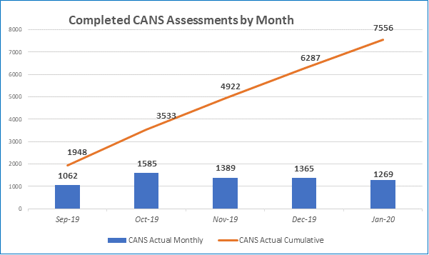

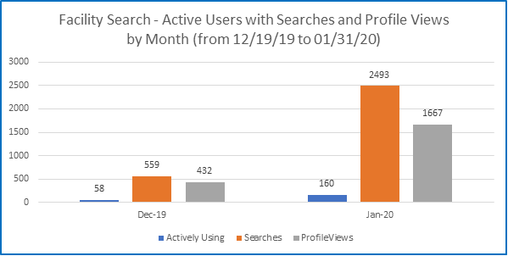

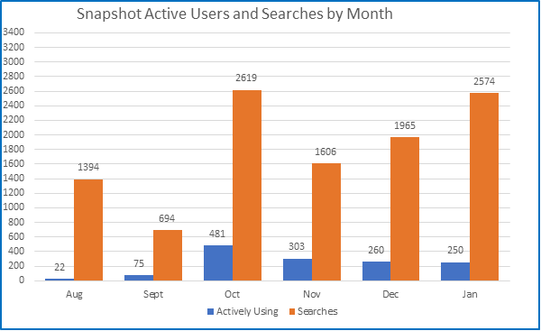

STAFFING VACANCY
Current Vacancy Rate: 21%
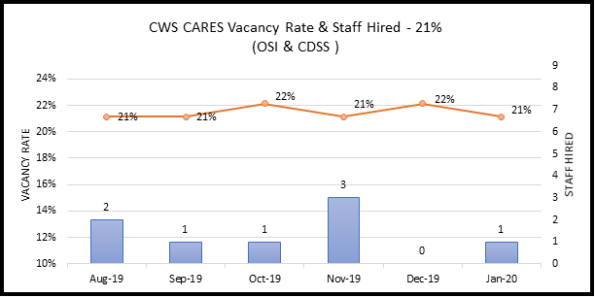
Current Vacancies - 22 of 104 CWS-CARES positions. The CWS-CARES vacancy rate has decreased from 22% to 21% since the last report.
Entity  CWS-CARES | Classification | Service Team | Date Vacant | # of Days  Vacant | Efforts/Notes
OSI | Associate Governmental Program Analyst | Procurement and Contract Management Analyst | 11/27/2019 | 49 | RPA under development
OSI | Information Technology Associate | Developer | 7/1/2017 | 928 | Position on hold
OSI | Information Technology Specialist I | Developer | 7/1/2017 | 928 | Position on hold
OSI | Information Technology Specialist I | Information Security Analyst | 7/1/2017 | 928 | Interviews began week of 1/6/20
OSI | Information Technology Specialist I | Information Security Analyst | 12/4/2019 | 42 | Interviews began week of 1/6/20
OSI | Information Technology Specialist I | Developer | 7/1/2017 | 928 | Position on hold
OSI | Information Technology Specialist I | Configuration Analyst | 7/1/2019 | 198 | RPA and Duty Statement under development
OSI | Information Technology Specialist I | Product Delivery Lead | 8/1/2019 | 167 | Position on hold
OSI | Information Technology Specialist I | Product Delivery Lead | 8/20/2019 | 148 | Position on hold
OSI | Information Technology Associate | Implementation Team Member | 1/12/2020 | 3 | RPA under development
OSI | Information Technology Specialist II | DevOps Engineering | 7/1/2017 | 928 | Interviews complete and offer anticipated in January
OSI | Information Technology Specialist II | Jira Administrator | 9/30/2019 | 107 | Interviews complete and offer anticipated in January
OSI | Information Technology Specialist II | Information Security Analyst | 9/14/2019 | 123 | Duty Statement being reviewed by OSI HR for posting
OSI | Information Technology Specialist II | DevOps Engineering | 7/1/2017 | 928 | Interviews will be held beginning 1/16/20
OSI | Information Technology Specialist II | Application Architect | 7/1/2017 | 928 | Interviews complete and offer anticipated in January
OSI | Information Technology Supervisor II | Data Management | 7/1/2017 | 928 | Position on hold
OSI | Information Technology Manager I | Product Chief | 7/1/2017 | 928 | Recruitment package under review – pending posting to CalCareers
OSI | Staff Services Manager II | Financial Manager | 10/30/2019 | 77 | Applicant selected and sent to HR for approval.
OSI | Staff Services Manager III | Administrative Services Manager | 1/6/2020 | 9 | Position under evaluation for redirection
CDSS | Associate Governmental Program Analyst | Licensing Program | 1/5/2018 | 740 | Position on hold
CDSS | Associate Governmental Program Analyst | Licensing Program | 6/28/2019 | 201 | Position on hold
CDSS | Information Technology Specialist I | Licensing Program Specialist | 7/12/2019 | 187 | Reposted as the candidate declined the offer; screening new applications

  - Filled Positions
Entity  CWS-CARES | Classification | Service Team | Date Vacant | # of Days  Vacant | Efforts/Notes
CDSS | Associate Governmental Program Analyst | Business Requirements Unit | 4/15/2019 | 262 | Official Start date is 1/2/20
OSI | Information Technology Specialist I | Lead OCM Analyst | 8/30/2019 | 136 | Official Start date is 1/13/20

RISKS
For this reporting period, there are two High Priority Risks. One new High Priority risks was opened, and no risks
were closed.

New Risks
New Risks | Impact | Resolution
Lack of information regarding Service Level Agreements for Salesforce License Subscription  RI-147  Description:  If the Service Level Agreement (SLA) for the PaaS License Subscription is not completed timely, the procurement schedule to obtain these licenses will be delayed. | The procurement of the Salesforce License Subscription may be delayed if the Project does not receive this information. This could result in the Salesforce Integration Services vendor onboarding prior to the Project procuring the Salesforce License Subscription. | Working with Risk owner on developing mitigation steps. One of these steps is working directly with Salesforce to gather the requested SLA information.  Progress as of 01/14/2020  The Project received some information from Salesforce and are working with the vendor for more information.

Continued Risks
Continued Risks | Impact | Resolution
Lack of Resource Overlap and Knowledge Transfer  RI-141 | By losing key contracted staff without the proper knowledge transfer to either state staff or other contracted vendors could cause a delay in the schedule due to new resources having to learn on the job. This could also impact the development of the CARES-Live and CRM-based PaaS solution, as the resources may not be available to assist with the development. | The Project plans to rehire key contracted resources and fill vacant positions within the Project.  Progress as of 01/14/2020:  This risk has been updated to include new impacts to the Project: The departure of technical resources knowledgeable in Kafka (i.e., Tom Parker and David Smith) could impact the support of CARES-Live 2.8, if there are any production issues with Kafka.  We are still working to determine a mitigation strategy. Work continues on this Risk with PCM and Project Leadership.

ISSUES
For this reporting period, there are no High Priority issues open. No High Priority issues were closed, and no new issues were added.

BUDGET/EXPENDITURES
as of January 15, 2020
2019-20 CWS-CARES Budget/Expenditure Report Summary
(Footnotes below)
OSI Spending Authority  Budget Item | 2019-20 Budget¹ | Actual Expenditures | Projected Expenditures | Total Actuals/ Projections
Personnel Services* | $9,935,256 | $2,021,223 | $5,907,609 | $7,928,832
Other OE&E** | $7,237,493 | $346,253 | $2,937,059 | $3,283,312
Data Center Services** | $4,000,000 | $1,362,931 | $2,532,664 | $3,895,595
Contract Services** | $12,894,183 | $4,628,287 | $6,856,004 | $11,484,292
Enterprise Services* | $3,088,032 | $381,810 | $1,352,392 | $1,734,202
OSI Spending Authority Total | $ 37,154,964 | $8,740,504 | $19,585,728 | $28,326,232

CDSS Local Assistance  Budget Item | 2019-20 Budget | Actual Expenditures | Projected Expenditures | Total Actuals/ Projections
Contract Services*** | $522,180 | $214,872 | $266,433 | $481,305
Other OE&E*** | - | - | - | -
County Participation Costs*** | $3,200,000 | - | $3,200,000 | $3,200,000
CDSS Local Assistance Total | $3,722,180 | $214,872 | $3,466,433 | $3,681,305

CDSS State Operations  Budget Item | 2019-20 Budget | Actual Expenditures | Projected Expenditures | Total Actuals/ Projections
Personnel Services**** | $1,930,359 | - | $1,930,359 | $1,930,359
Facilities**** | $568,000 | - | $568,000 | $568,000
Other OE&E**** | $224,497 | - | $224,497 | $224,497
CDSS State Operations Total | $2,722,856 | - | $2,722,856 | $2,722,856

Project Totals | 2019-20 Budget | Actual Expenditures | Projected Expenditures | Total Actuals/ Projections
CWS-CARES Project Total | $43,600,000 | $8,955,376 | $25,775,017 | $34,730,393
¹ 2019-20 Budget reflects amount in FY 2019-20 Governor's Budget
* Actuals through September 2019 per FI$Cal Report
** Actuals from September 2019 Fi$CAL Reports, in addition to processed invoices through January 16, 2020
*** Actuals from CDSS as of September 2019
**** Actuals per CalSTARS Report (no actuals have been received for FY 2019-20 to-date)

Questions? Email CWDS Communications: comms@cwds.ca.gov

