CARES Implementation Portal Job Aid

Purpose
The purpose of this Job Aid is to show you how to:
- Navigate to CARES Implementation Portal
- Register to Access CARES Implementation Portal
- Access CARES Implementation Resources
Background:
The CARES Implementation Portal is used to provide resources to the County, Probation, and Regional Training Academy users. The Implementation Portal provides Tools and Templates, Frequently Asked Questions (FAQs), latest updates and many resources. The resources provided pertain to CARES Implementation Management, Organizational Change Management (OCM) and Training.

Portal Navigation
There are various access points to CARES Implementation Portal. You may access the portal from the main CWS/CMS website, www.hwcws.cahwnet.gov, or from CARES Implementation Portal, https://cwscms.osi.ca.gov.

CARES Implementation Portal Navigation
To get started, navigate to CARES Implementation Portal using one of the methods described below.

Navigate to CARES Implementation Portal using http://hwcws.cahwnet.gov:

Step | Action | Result
1. | Navigate to CWS/CMS website http://hwcws.cahwnet.gov | CWS/CMS website main page displays.
2. | Click Implementation Portal on the left navigation pane | Welcome to CARES Implementation Portal page displays.
3. | Click on Login | CWS User Login page displays.

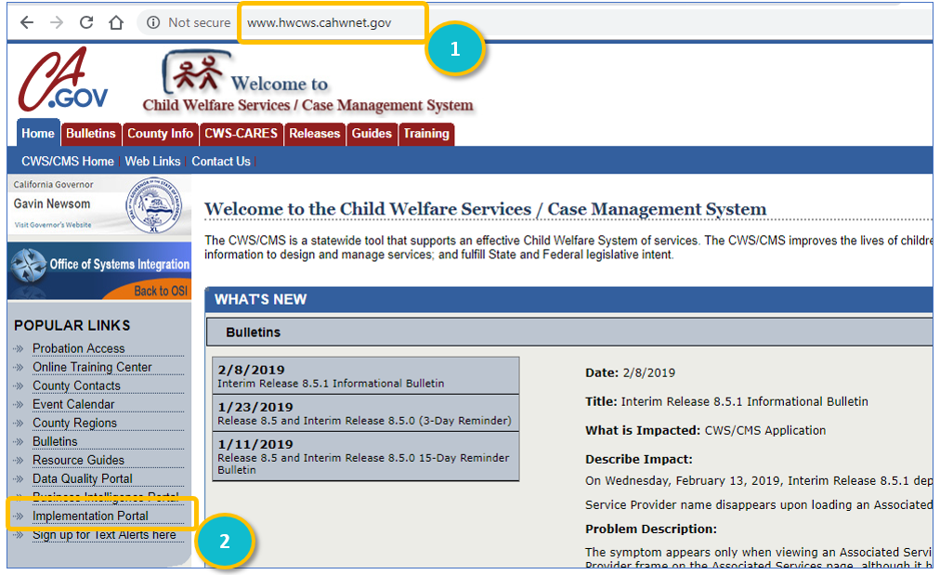

Navigate to CARES Implementation Portal using https://cwscms.osi.ca.gov:

Step | Action | Result
1. | Navigate to CARES Implementation Portal, https://cwscms.osi.ca.gov | Welcome to CWS-CMS portal displays.
2. | Hover mouse over CWS-CARES | CARES Implementation link displays.
3. | Click CARES Implementation Portal | CARES Implementation Portal page displays.
4. | Click Login | CWS User Login page displays

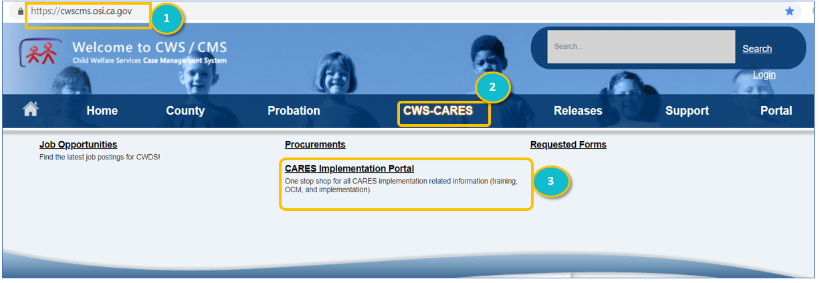

Accessing Implementation Resources:

Step | Action | Result
1. | From the CARES Implementation Portal page click Login | Login page displays.
2. | Enter Username, Password, and click Login | Welcome to The CARES Implementation Portal page displays.

Note:
Registration is required to access all CARES Implementation resources. If you forgot your password, click on the reset password button on the Registration page. Please send an e-mail to the Implementation Training Team, osicwdstraining@osi.ca.gov, if you need assistance.

Register to Access CWS-CARES Implementation Resources:

Step | Action | Result
1. | Navigate to the CWS/CMS web page, https://cwscms.osi.ca.gov | Welcome to CWS/CMS page displays.
2. | Click on the Login button | CWS User Login page displays.
3. | Click the Register button | Account Registration page displays.
4. | Complete all seven required fields marked by an asterisk and click Register | Registration email is sent to user.

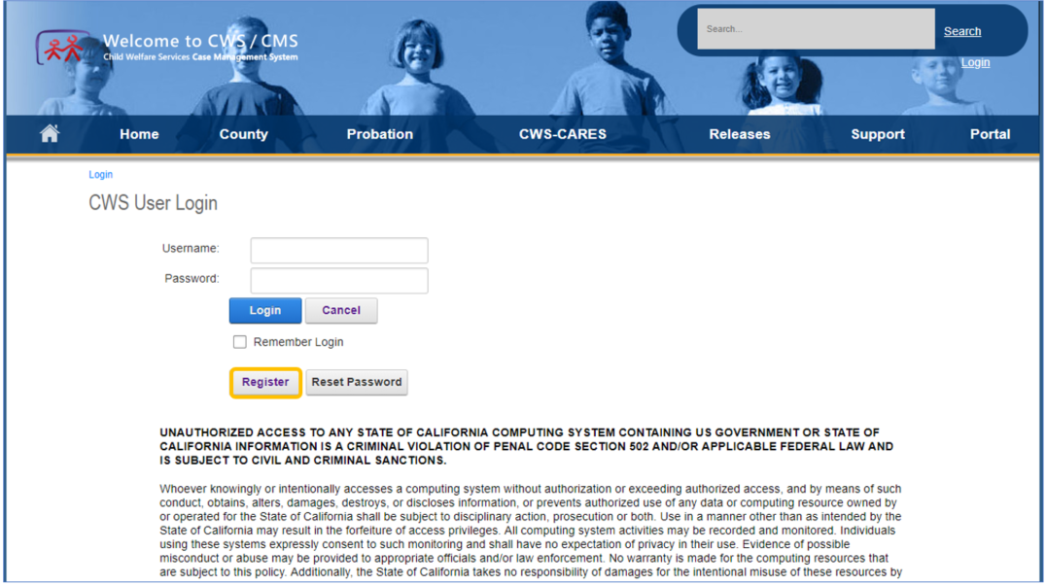

Note:
CWS-CARES Training website credentials are not the same credentials you use to access the CWS/CMS application.

Navigating the Implementation Portal
The Implementation Portal landing page contains information about latest updates with quick access links. Document folders and sub-folders are accessed on the right. Use the breadcrumbs navigation to return to the Implementation Portal main page.

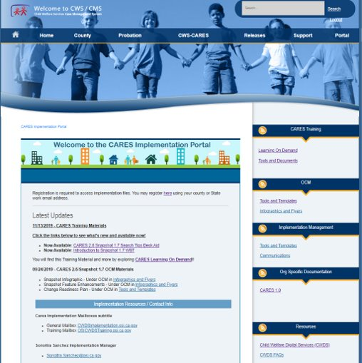

CARES Implementation Support
If you need help with any of the information in this document, please contact your assigned Implementation Lead or email Implementation, cwdsimplementation@osi.ca.gov

Is This Job Aid Helpful?
If you have questions or suggestions regarding this job aid please e-mail CWDS Training, osicwdstraining@osi.ca.gov.

