October 16, 2019 through November 15, 2019

VISION STATEMENT
“We will establish and maintain an innovative statewide 21st century information technology application that aids child welfare stakeholders in assuring the safety, permanency, and well-being of children at risk of abuse and neglect.”
Child Welfare Digital Services (CWDS) is a collaboration of California State and local government agencies that support our shared stakeholders through technology to assure the safety, permanency and well-being of children at risk of abuse, neglect or exploitation. CWDS is responsible for maintaining and operating the existing Child Welfare Services / Case Management System (CWS/CMS) and the development of the Child Welfare Services – California Automated Response and Engagement System (CWS-CARES). We are dedicated to building a child welfare information system that responds to users’ needs while maintaining the best standards for security and data integrity to aid child welfare professionals in the vital assistance, oversight and case management of our most vulnerable populations.

HIGHLIGHTS
The decision to select Salesforce as the Platform as a Service (PaaS) solution was announced at the Quarterly Legislative Briefing on October 30, 2019. The maturity of the Salesforce platform will allow CWDS to accelerate development of CARES. To ensure sufficiency of planning and managing the configuration of the application, the Project will procure an experienced vendor in integration services so that CARES is developed effectively. Additionally, the Project will procure a vendor for the development of the CARES Data Infrastructure (CDI), and a vendor to ensure the value of what is being built, appropriately titled Product Value Services. These primary vendors will provide guidance and consultation to the Project to build future capacity of CARES.

The Project’s integrated technical solution is building CARES using the Salesforce PaaS that will integrate with the CARES Data Infrastructure (CDI) to comply with federal Comprehensive Child Welfare Information System (CCWIS) and state requirements. Transition planning to PaaS will be through June 2020. During this month, the Project focused on developing key Governance documentation, such as the CARES Service Delivery Lifecycle Governance Model and the Vendors’ Key Responsibility Chart. The Project also continued to conduct discovery activities with Subject Matter Experts (SME’s) for Screening and RFA business processes.

On October 28, 2019, the Project successfully implemented the final phase (Phase 4-Wave 4) of CARES-Live Release 2.6, thus concluding the statewide rollout of Snapshot 1.7 and bringing the total number of users to 6,152. This release included resolution of the search pipeline latency and provided search results in near real-time synchronization with CWS/CMS. On November 4, the Project announced the upcoming CARES-Live user bulk load opportunities, which will also follow a phased rollout approach divided into three waves on November 18, November 25 and December 3. This will provide organizations with the opportunity to request access to any or all CARES-Live feature-sets (Child and Adolescent Needs and Strengths [CANS], Snapshot, and Facility Search).

On October 28, the Project distributed a survey to 8,484 CARES-Live users and within one week received 1,134 responses. The intent of the survey was to solicit CARES-Live user feedback on the three CARES-Live features (Snapshot, Facility Search and CANS) to better understand and evaluate users experience in usage of CARES-Live features. The Project is in the process of analyzing and summarizing the survey results during the month of November.

Stakeholder outreach continues to provide CARES and CARES-Live Project status updates and demonstrations to the Regional User Groups and California Department of Social Services (CDSS) during this reporting period. In addition, Implementation activities continue to gain momentum by providing support and learning opportunities to increase awareness and adoption of the CARES-Live features. This includes web-based training, demos, videos, and job aides on CARES-Live functionality. These efforts provide CARES-Live users several opportunities to engage in a variety of ways to learn how to use CARES-Live.

CARES-Live Release 2.7 is scheduled for November 16, which will include bug fixes and enhancements to the user metrics tool (New Relic) reporting capabilities for Snapshot, as well as security related identity management fixes. For further details related to this release, please reference the CARES-Live Release Status section below.

The Project continues to collaborate with the California Department of Technology (CDT) and Department of Finance (DOF) to update the Special Project Report (SPR) 3 for a Fall 2019 submission.

KEY PROJECT MILESTONES
Milestone | Planned Finish Date | Actual Finish Date | Status | Notes
Special Project Report 3 (SPR 3) Submission | 11/30/2019 |  | In Progress | An updated draft SPR 3 was submitted on October 18, 2019. The Project is addressing critical partner feedback with a goal to circulate the final SPR 3 update for signatures and submission in Fall 2019.
CARES-Live 2.6 Implemented Statewide | 11/04/2019 | 10/28/2019 | Completed | The Project released CARES-Live 2.6 Phase 4-Wave 4 on October 28, 2019. This concluded the Project’s statewide rollout of Snapshot 1.7, bringing the total number of provisioned users to 6,152.
Release CARES-Live 2.7 | 11/16/2019 |  | In Progress | On October 2, 2019, the Executive Leadership Team (ELT) approved the release of CARES-Live 2.7. This release includes enhancements for user metric reporting capabilities for Snapshot and bug fixes for Snapshot, as well as security related identity management fixes.
Product Roadmap Updated Quarterly (FY 2019/20 Q2) | 10/01/2019 | 09/26/2019 | Completed | The Quarterly Product Roadmap was updated on September 26, 2019. The update reflects recent Product Blueprint refinement sessions that reshape/rename some of the Product Building Blocks.
Project Roadmap  Updated Quarterly  (FY 2019/20 Q2) | 12/31/2019 |  | In Progress | The Quarterly Project Roadmap was last updated on November 13, 2019. The update reflects recent Project Roadmap refinement sessions that realign upcoming key milestone dates with the pending SPR 3 approval.
CWS-CARES Playbook | 11/30/2019 |  | In Progress | The CARES Service Delivery Playbook was completed on August 19, 2019. Detailed Playbook “plays” (tactical instructions) are currently under development by Delivery Central.
Decision on Continuation of CARES-Live | 01/2020 |  |  | The Project has released three CARES-Live feature-sets to date: CANS, Facility Search and Snapshot. After calendar year 2019, the Project will assess the costs and benefits of continuing to support CARES-Live.
Implementation Advance Planning Document Submitted to ACYF | 04/2020 |  | In Progress
PaaS Integration Services Procurement | 08/11/2020 |  | In Progress | The Solicitation was released on November 7, 2019.
PaaS Licenses Procurement | 06/02/2020 |  | In Progress | The Project is collaborating with CDT STP to develop the RFO.
CARES Data Infrastructure Procurement | 10/02/2020 |  | In Progress | The Solicitation is ready for ACYF review and approval.
Product Value Services Procurement | 06/15/2020 |  | In Progress | The Project is collaborating with CDT STP to develop the RFO.

October 16 through November 15, 2019

CARES-LIVE RELEASE STATUS

Product Feature/Service - Progress to Date
With the Project's decision in May 2019 to pursue a Customer Relationship Management (CRM) based PaaS solution, the Project is no longer actively managing the backlogs/work queues for the team to introduce new features to CARES-Live. The Project, however, is committed to evaluating enhancements and features that would increase adoption of CARES-Live (CANS, Snapshot and Facility Search). All feature enhancement requests will be evaluated against user adoption goals, and, the Project will continue to reassess the costs and benefits moving forward.

CARES-Live Release 2.7

Snapshot Enhancements and Bug Fixes
- Configure and capture User Metrics for New Relic report
- Update search behavior to disable the ability to search when information previously entered into field is removed by a user
- Address the field constraints for SSN & Client ID
- Refactor GitHub repository for future releases of Snapshot

Identity Management (IDM) Security Updates
- Remove HTTP caching software called “Varnish” from the Cognito code
- Remove all external requests to load Fonts, Style Sheets and JS files from non-trusted software repositories so that Cognito Login page cannot load them

CANS Enhancements
- Update CANS items to match updated CANS Rating Form
- Update CANS Duplicate Client Reconciliation Repor

Implementation Activities
- Completed activities for statewide rollout of Snapshot 1.7 and as of 10/28/2019 the statewide rollout is complete.
- Preparing to bulk load users. Offering to bulk load users to counties can gain access to one or all of the CARES-Live feature sets: Snapshot, CANS Facility Search
  - 3 Waves of bulk loading: Wave 1 on 11/18/2019, Wave 2 on 11/25/2019 and Wave 3 on 12/3/2019.
- Analysis of CARES-Live user metrics and track county feedback to provide ELT with weekly updates about CARES-Live adoption and county feedback

Organizational Change Management
- Identified a strategy and plan for county outreach efforts in support of county level implementation and adoption of CARES-Live tools.
- CARES-Live survey conducted to gather user feedback. Conducted analysis of survey results.
- Attended several Regional User Group meetings and Children's outreach meetings to provide implementation and release updates

User Training
- Finalized web-based training (interactive learning video) for Snapshot 1.7 and posted to the CWDS Implementation Portal
- Updated training material to support the CARES 2.7 release, scheduled for 11/16/2019
- Participated in discussions and facilitated next steps for the Training Environment regarding user access and data validation
- Created data for the training environment

CARES-Live METRICS
Month | FACILITY SEARCH  # Sessions | SNAPSHOT  # Users Activly Using | CANS  # Completed Assessments
May | 97 | 12 | 94
June | 232 | 12 | 115
July | 210 | 21 | 182
August | 264 | 22 | 377
September | 235 | 74 | 1061
October | 326 | 487 | 1585
Thru – Nov 12th | 79 | 141 | 505

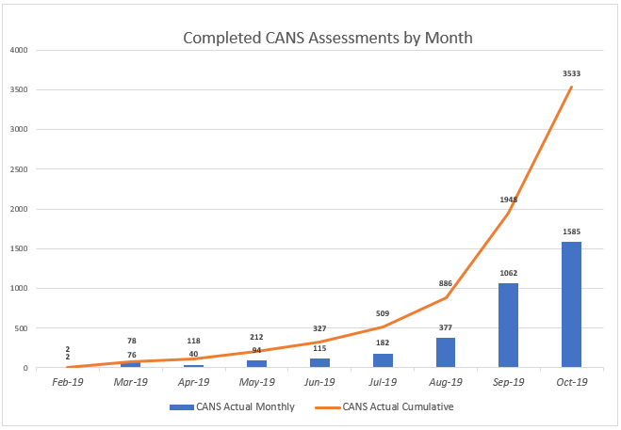

STAFFING VACANCY
Current Vacancy Rate: 20%
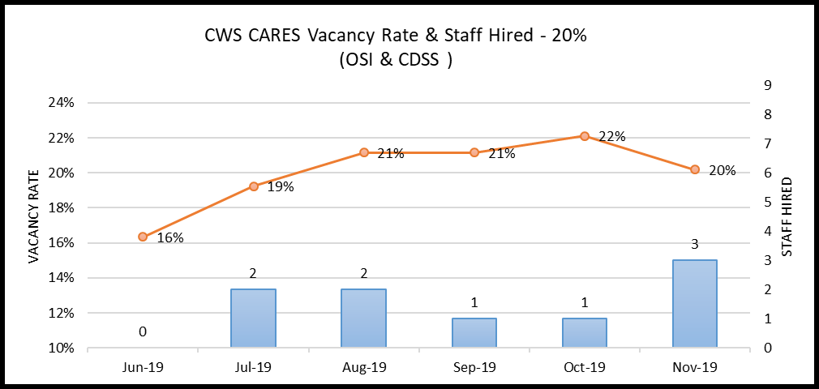
Current Vacancies - 21 of 104 CWS-CARES positions. The CWS-CARES vacancy rate has decreased from 22% to 20% since the last report.
Entity  CWS-CARES | Classification | Service Team | Date Vacant | # of Days  Vacant | Efforts/Notes
OSI | Information Technology Associate | Developer | 7/1/2017 | 867 | Position on hold.
OSI | Information Technology Manager I | Product Chief | 7/1/2017 | 867 | Position will be posted in recruitment in November 2019.
OSI | Information Technology Specialist I | Developer | 7/1/2017 | 867 | Position on hold.
OSI | Information Technology Specialist I | DevOps Engineering | 9/30/2019 | 46 | RPA under construction—justification being routed for approval.
OSI | Information Technology Specialist I | Information Security Analyst | 7/1/2017 | 867 | Position posted, final filing date 11/23/19.
OSI | Information Technology Specialist I | Developer | 7/1/2017 | 867 | Position on hold.
OSI | Information Technology Specialist I | DevOps Engineering | 7/1/2019 | 137 | RPA and Duty Statement under development—justification being routed for approval.
OSI | Information Technology Specialist I | Product Delivery Lead | 8/1/2019 | 106 | Position on hold.
OSI | Information Technology Specialist I | Product Delivery Lead | 8/20/2019 | 87 | Position on hold.
OSI | Information Technology Specialist I | Implementation Team Member | 8/30/2019 | 77 | HR reviewing RPA and Duty Statement.
OSI | Information Technology Specialist II | DevOps Engineering | 7/1/2017 | 867 | Position posted, final filing date of 11/18/19.
OSI | Information Technology Specialist II | Information Security Analyst | 9/14/2019 | 62 | Duty Statement being reviewed by OSI HR for posting.
OSI | Information Technology Specialist II | DevOps Engineering | 7/1/2017 | 867 | Position posted, final filing date of 11/18/19.
OSI | Information Technology Specialist II | Application Architect | 7/1/2017 | 867 | RPA and Duty Statement under development.
OSI | Information Technology Supervisor II | Data Management | 7/1/2017 | 867 | Position on hold.
OSI | Staff Services Manager II | Financial Manager | 10/30/2019 | 16 | Applicants being screened as of 11/12/19.
CDSS | Associate Governmental Program Analyst | Program Policy | 11/1/2019 | 14 | RPA and Duty Statement under development.
CDSS | Associate Governmental Program Analyst | Business Requirements Unit | 4/15/2019 | 214 | Candidate selected and package sent to HR for approval.
CDSS | Associate Governmental Program Analyst | Licensing Program | 1/5/2018 | 679 | Position on hold.
CDSS | Associate Governmental Program Analyst | Licensing Program | 6/28/2019 | 140 | Position on hold.
CDSS | Information Technology Specialist I | Licensing Program Specialist | 7/12/2019 | 126 | Candidate selected and package sent to HR for approval.

  - Filled Positions
Entity  CWS-CARES | Classification | Service Team | Date Vacant | # of Days  Vacant | Efforts/Notes
OSI | Information Technology Specialist I | Procurement and Contract Management Analyst | 8/8/2019 | 99 | Position filled, Official Start Date 11/5/2019
OSI | Information Technology Specialist I | DevOps Engineering | 7/1/2017 | 867 | Position filled, Official Start Date 11/12/2019
OSI | Information Technology Specialist I | Developer | 7/1/2017 | 867 | Position filled, Official Start Date 11/4/2019

RISKS
For this reporting period there was one High Priority risk open. No High Priority risks were closed.

New Risks
New Risks | Impact | Resolution
Lack of Resource Overlap and Knowledge Transfer  RI-141 | By losing key contracted staff without the proper knowledge transfer to either state staff or other contracted vendors could cause a delay in the schedule due to new resources having to learn on the job. This could also impact the development of the CARES-Live and CRM-based PaaS solution, as the resources may not be available to assist with the development. | The Project plans to rehire key contracted resources and fill vacant positions within the Project.

ISSUES
For this reporting period, there are no High Priority issues open. No High Priority issues were closed, and no new issues were added.

BUDGET/EXPENDITURES
as of November 15, 2019
2019-20 CWS-CARES Budget
CWS-CARES Budget | 2019-20 Budget
CWS-CARES Spending Authority Total | 26,000,000

CDSS State Operations Budget Item | 2019-20 Budget
CDSS State Operations Total | 2,722,856

CWS-CARES Project Total | 28,722,856

Delivery Central is a steering body that functions as the coordination hub for the CARES Service Delivery Lifecycle. The purpose of this steering body is to support and guide, following CWS-CARES Product Development Guiding Principles, cross-functional delivery teams through all lifecycle phases.

